Adaptive UI as an office work support tool using changes in ambient noise

Connor Murphy

MSc Applied Artificial Intelligence and User Experience, 2025

School of Design and Informatics
Abertay University

Table of Contents

Table of Figures iii
Acknowledgements v
Abstract vi
Abbreviations, Symbols and Notation viii
Chapter 1 Introduction 1
1.1 What are Adaptive User Interfaces? 1
1.2 How Was This Done 3
1.3 Research aims and Objectives 4
Chapter 2 Literature Review 5
2.1 Adaptive User Interfaces 5
2.2 Keyboard Dynamics 8
2.3 Coloured Noise 11
2.4 Collecting user experience 13
2.5 Summary 14
Chapter 3 Methodology 16
3.1 Development methodology 16
3.2 PsychoPy and Python Libraries 17
3.2.1 NumPy 17
3.2.2 Json 18
3.3 Experiment Environment 18
3.4 Experiment Structure 19
3.5 Programmed Elements 23
3.6 Keyboard Dynamics Analysis method 35
3.7 Surveys Analysis 37
3.8 Significance Measures for results 40
Chapter 4 Results 42
4.1 Keyboard Dynamics Results 42
4.2 SUS Survey Results 47
4.3 UEQ Survey Results 48
4.4 Perceived Difficulty Results 49
Chapter 5 Discussion 51
5.1 High level Issues 51
5.2 Experiment Elements 52
5.3 Possible Mechanisms 56
Chapter 6 Conclusion and Future Work 58
6.1 Conclusion 58
6.2 Future Works 59
List of References 60
Appendices 63
Appendix A Gannt Chart 63
Appendix B Code Components 64
Appendix C Experiment Elements 68
Appendix D Analysis 70
Appendix E: GDPR Data Management Data Sign Off Form 84

Table of Figures
Figure 2.1 A diagram of a proposed AUI model (Miraz,2021). 7
Figure 2.2 A diagram of the calculations for getting the timings Maalej et al used in their experiment (Maalej et al, 2022). 10
Figure 2.3 A diagram of various coloured noises and their frequency ranges (Soundly.com, 2025) 12
Figure 3.1 A diagram of the overall flow of the experiment 20
Figure 3.2 screen shots of the finalised timeline of the experiment 20
Figure 3.3 example of a PDAQ taken form the PDAQ workshop PowerPoint 22
Figure 3.4 snippet of code used to collect IKIs of participants 23
Figure 3.5 snippet of code used to calculate the 75th percentile of the
participants 25
Figure 3.6 snippet of code used to collect KDs metrics of participants 26
Figure 3.7 snippet of code that shows the conditions to activate the
delCheck flag 27
Figure 3.8 snippet of code that shows the calculations that are used to determine how many valid pauses have occurred. 29
Figure 3.9 snippet of code that shows the check used to activate the IKICheck flag. 31
Figure 3.10 snippet of code that activates the AUI change. 32
Figure 3.11 snippet of code that collates all of the recorded data in Json format. 34
Figure 3.12 RQA plot showing the recurrence of a sine wave (Wallot, 2017) 35
Figure 3.13 Graph showing SUS score against percentile
(Measuringu.com, 2024) 38
Figure 3.14 Scoring graph from the UQE data analysis tool. 39
Figure 4.1 A Selection of RQA Plots taken from both the control and adaptive groups. 42
Figure 4.2 Box and whisker plot showing the difference in the proportional RQA metrics. 43
Figure 4.3 Box and whisker plots showing the difference in RQA average length of diagonal and vertical lines. 43
Figure 4.4 Box and whisker plot showing the difference in RQA entropy a measure of diversity of diagonal lines. 44
Figure 4.5 Box and whisker plot showing the difference in Levenshtein edit distance a measure of difference. 45
Figure 4.6 Box and whisker plot showing the difference in Levenshtein radio a measure of similarity. 45
Figure 4.7 Box and whisker plot showing the difference in percentage time metrics scores. 46
Figure 4.8 Box and whisker plot showing the difference in SUS survey scores. 47
Figure 4.9 Box and whisker plot showing the difference in UEQ survey scores 48
Figure 4.10 Box and whisker plot showing the difference in the perceived difficulty and length of the task alongside the cooking experience 49

Acknowledgements
This paper would like to acknowledge Professor Vera Kampe and Dr Andrea Szymkowiak for support and design suggestions.

Abstract
The aim of this Project is to evaluate whether an adaptive UI developed to improve office work efficiency through coloured noise, thus improving user experience, and whether it can be practically applied. As the number of office jobs increases, the importance of job satisfaction does so too. However, many office workers find some aspects of their work tedious. This project believes that if the experience of completing a task is enjoyable, the person doing the task will complete it more efficiently. To do this an office work support tool was developed using an adaptive user interface to reduce mental stress. An adaptive user interface is s system that adapts its user interface based on the user and their interactions with it. The adaptive user interface this project developed triggers based on specific keyboard dynamics metrics that represent high mental stress. Once high mental stress is detected, the adaptive user interface will alter the background noise to a coloured noise. Coloured noises are specific bands of frequencies at different powers. Studies have shown that coloured noise improves cognitive performance and memory recall, among other benefits. This is theorised to happen due to a phenomenon known as stochastic resonance, where coloured noise resonates with the neurons in the brain, helping neural signals to be fired more easily. This Project's theory is that the coloured noise will refocus and support the participant when they start to struggle with the task, therefore, improving both task accuracy and overall user experience. To test this system, the participant completed a summarisation task of writing up a recipe from an instructional video they had just watched. This task is intended to simulate the writing task of reporting and summarising data seen in many office work type tasks. The adaptive system was AB tested against a non-adaptive system with analysis focused on finding significant differences between the groups' keyboard dynamics, task accuracy, the usability of the system, the experience of using the systems, and the participants' perceived difficulty of the task. None of the recorded metrics had any significant difference between the two groups. As this Project was exploring a novel approach combining adaptive user interfaces, keyboard dynamics and coloured noises, it was decided to treat this Project as a pilot study and discuss improvements that could be made to improve the methodology of this Project. The suggestions were test with more participants, redevelop the support tool from the ground up to ensure smooth interactions and expand the recorded metrics to have more granularity to properly explore any underlying relationships. This project still believes this topic is worthy of further exploration, mainly due to possible practical applications.

Abbreviations, Symbols and Notation
Adaptive User Interface (AUI)
Keyboard Dynamics (KD)
Inter-Key Intervals (IKI)
System usability survey (SUS)
User Experience Questionnaire (UEQ)
User Experience (UE)
Human Computer Interactions (HCI)
Recurrence Quantification Analysis (RQA)
Perceived Difficulty Assessment Questionnaire (PDAQ)
Recurrence Rate (RR)
Determinism (DET)
Average Diagonal Line Length (Lmean)
Entropy (ENTR)
Laminarity (LAM)
Trapping time (TT)

Chapter 1 Introduction

According to the UK Office for Statistics, the number of workforce jobs was 37.1 million as of March 2025. Evidence of the 4.2% increase since the end of COVID-19 in 2020 (Labour Market team, 2025). The majority of these jobs and the workforce in the future will require some form of office work. Writing reports, drafting emails, researching topics and maintenance files are all tasks that keep companies functioning. Issues can arise with morale and high staff turnover as many people find the vital tasks quite tedious. However, it has been proven that a better user experience (UE) improves work performance, AKA if you have a good time doing a task, you are more likely to finish it and make fewer or in some cases no mistakes. This Project sees this relationship as an opportunity to improve both job satisfaction and work efficiency by developing an office work support tool. This project will accomplish this through the utilisation of adaptive user interfaces (AUIs).

1.1 What are Adaptive User Interfaces?
The theory behind AUIs has been studied since Human Computer Interactions (HCI) founding, and most people will have used multiple AUIs every day without realising. AUI at its most fundamental level is a design approach where the UI alters the elements it is composed of automatically in accordance with the preferences and needs of the user, in an attempt to improve the flow of the UI for a given task, while appealing to the user’s aesthetic tastes. Thereby improving UX through both function and form. AUIs are practically implemented in a wide range of systems, the most well-known implementations are web pages altering their layout and elements based on the hardware accessing it (I.E., laptop, phone, TV or gaming console). Similarly, there are GUIs that activate light or dark versions based on environmental light levels. There are even AUIs in GPS systems that alter when a wrong turn is taken. These implementations are mostly seen on consumer-centred digital systems such as entertainment systems, social media websites or apps and any system that needs to constantly update displayed information.

As artificial intelligence (AI) has grown in prominence, its ability to quickly process data and find hidden relationships has helped it become the main method used in AUIs for dictating what and when changes in the UI. There are numerous types of data used in the training of AI and further analysis before any adaptation is made to the UI. The most widely used type of data is a user’s preferences. Reminiscent of the systems used to target specific advertisements towards the most receptive audience. The user’s data is collected through a number of means, but most likely it is scraped from the internet. The required data is focused on the user's aesthetic interest, like their favourite colour combinations, their preferred font size and if they have disabilities that act as an obstacle to interacting with the system, i.e. colour blindness. Also of importance are the types of tasks they use the system for and specifically what tools within the system they use to complete the task. Scraping user data from the internet is dubiously ethical at best. Experts in the field have theorised that this kind of data would be the best type suited for use in an AI driven AUI (Miraz, 2021).

In office work programs like the Microsoft Office family of applications, AUI have never been utilised. Meaning there are very little to no research papers exploring their implementation. Office work programs usually do allow for limited user restructuring of icon placement, but nothing like the complete alteration of elements that AUIs are capable of. They are what are termed “Constant Interfaces”, meaning the major parts of the UI are unchangeable by the user at any level of access. This is done to optimise performance by standardising how documentation is created or edited while also streamlining the flow of data within a company. However, this prioritises usability over the UE, which has an effect on staff motivation among other things. Angela Carrera-Rivera touches on this topic in their paper on developing a dataset of human interaction of AUI use, “manufacturing companies should consider factors related to user motivation” (Carrera-Rivera, 2023). A person who revels in the work process is far more likely to be productive. Recognising the gap in research, this project developed a hybrid system whose main UI elements follow the rules of constant interfaces. However, it also has an AUI implemented, which alters minor background UI elements so as not to interfere with the work but still improve overall UX through proven mental stress reducing measures.

1.2 How Was This Done
This Project required the implementation of both psychological and user experience methodologies. Within the field of psychology, numerous methods of identifying and measuring mental stress have been developed, some of which mirror common tasks seen within office workspaces. This project chose memorising a recipe. This requires summarisation skills, which are also used when summarising data for reports. As AUI products are primarily focused on improving user experience with no direct connection to lowering mental stress, the specific UI changes were re-examined in this new context. After an investigation, it was decided to implement coloured noise as the adaptation. The altering of background noise does not interfere with the constant interface elements the user interacts with to complete the task, there has also been experiments where playing coloured noise over an office space improved efficiency overall. This project aimed to mimic these findings on an individual worker level. The control mechanism for triggering the adaptation was keyboard dynamics (KD). KDs were chosen over the traditional AI implementation due to the need for real-time measuring of mental stress. An AI would have taken too long to make the estimation; also, no data set specifically exists for estimating mental stress through KD with which to train it.

1.3 Research aims and Objectives
The main aim of this Project is to evaluate whether an adaptive UI developed to improve office work efficiency through coloured noise thus improving UX can be practically applied.

To do this, several key objectives must be completed.
- Research AUI's functionality and implementations.
- Research unobtrusive methods to deduce task performance in real time.
- Evaluate methods of improving UX without causing disruption to the workflow.
- Develop an AUI based on previous findings.
- Implement a task resembling office work into the AUI and devise a method of evaluating the results of the task for accuracy.
- Develop an AB testing experiment with a non-adaptive version and the developed AUI. Compare the usability, UX and task performance between the two.

With these objectives, the Project was able to evaluate the proposed office work support tool fully, by testing for both, improved work efficiency and UX.

Chapter 2 Literature Review
To properly discuss AUI, this proposal will first explore the broad topic and principles. Then, the discussion will turn to coloured noises and their effect on mental cognitive ability.

2.1 Adaptive User Interfaces
To help understand the details of the topic, Mahdi Miraz wrote a literature review on the topic. Throughout the review, Miraz criticises modern software as being “written by people who are young and highly IT-literate and they thus design software which only caters to their own requirements.” (Miraz, 2021). Miraz specified that the elderly and disabled are hurt most by this trend. Sadly, this trend is most likely to grow as systems become more complex. Instead, Miraz posits that all digital products should cater to the full spectrum of human need and ability. One of the best solutions are AUIs, which can automatically update the UI functionality based on user skill and preference. Miraz highlighted three main principles core to AUIs: universal usability, the placidity of user interface design and the adaptation methods used by these systems.

Universal usability, in this case, as touched on before, means how a digital product caters its usability to all types of users. This is why the field of human-computer interactions (HCI) has been so heavily researched for decades. To ensure that digital goods and services are accessible to as many people as possible. However, as said by A.F. Newell, by accommodating a group with one disability, you may be making it harder for users without said disability. (Newell, 2002) This means that it is extremely difficult to get truly universal usability; however, with AUIs and their ability to completely remake their UI, it is possible to cater to opposing needs in a single digital product.

The placidity of an application, according to Miraz, is how the application changes the information being displayed, how the user interacts with the information being shown and the data these adaptations are built on. These adaptive systems can be very complex, but essentially an adaptive application will take data about a particular user, the task the user is completing, colour preference, main language and many other things, then build the UI based on that data, for example.

The methods of adaptation are wide, with even the amount of computer adaptation having levels. These are highlighted in a paper that used AUIs in combination with the easy reading framework. A support system for improving accessibility for the cognitively disabled (Heumader, 2020). On one end, there is fully manual adaptation where the user has full control over the UI. On the other the AUI has full control. In between, the minority takes on a support role, making suggestions and asking the majority for permission before making any changes. So, if the AUI is the majority, it will ask the user before making changes and vice versa. The main method AUIs use to make the decision on when and what to change is AI in a system similar to the one shown below in Figure 2.1.

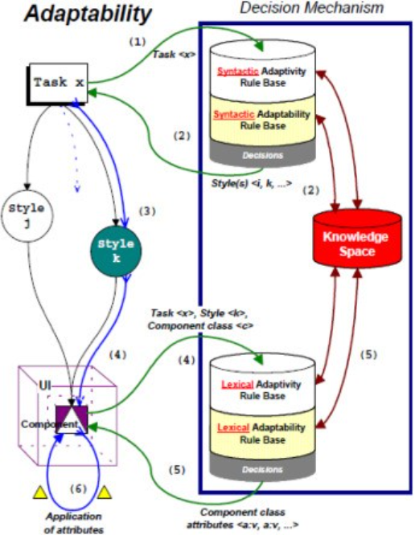
Figure 2.1 A diagram of a proposed AUI model (Miraz,2021).

The AUI AI holds data on the user, their preferences, interaction methods and so on. It also takes in the task the user wants to complete, how they completed it and if they satisfactorily completed the task. Then, based on all of this input, the AUI adapts the UI either through selecting premade elements or generating new code. Either way, the AUI chooses the best UI to support the user in completing the task. However, the method and data used for the change are highly dependent on the main use of the system the AUI is built into, such as streamlining industrial robots based on user characteristics, adjusting the haptic feedback in flight suits and controls in a simulator based on flying conditions or support for large-scale software development (Miraz, 2021). For the current Project a feasible and unobtrusive method for investigating the effects of an adaptive tool to a particular task at hand was chosen. Specifically, the effect of steady and adaptive noise on typing behaviour was investigated.

2.2 Keyboard Dynamics
In terms of data that can be used to evaluate stress caused by performing office-type tasks in real time, there has been a method that has been rigorously tested and proven to correlate with mental stress. This method involves tracking of key stroke dynamics (KDs). KDs is the method of analysing a person’s typing habits to determine features about the user. There are many different metrics within KDs, such as the timings between button presses, the rhythm the user makes when using a keyboard, the amount and placement of revisions and the point at which the user pauses. Each of these metrics are individually considered indicative of various mental states, just like biomarkers. However also like biomarkers, KD metrics are generally used in combination to better represent a particular mental state.

KDs has been tested in a few different areas of study, most particularly in user authentication. Since a person’s KDs is unique to them, akin to handwriting, it has long been theorised that it could be used to authenticate the user (Shadman et al, 2025). This line of theory does highlight a few key aspects of consideration when dealing with KDs. Within KDs, there are two main types of data: fixed and free. Is the user typing the same text each time, or are they writing whatever they like? In the case of authentication, the data is naturally fixed as a user is almost always going to type their password the same way each time. However, it is not exclusive, as shown by Rashik Shadman et al. When they performed a literature review on the topic. They reviewed datasets used by past papers and found that the majority were fixed or a mix of fixed and free, with a handful of free typing datasets (Shadman et al, 2025). The exact method each paper used for the classification varied between algorithms and AI-based models, with error rates varying between <0.01 and < 20.00, showing that using this method of authentication is generally very good but not perfect. Despite this, Shadman et al did identify a very useful benefit for systems utilising KDs, that being “deployment of keystroke dynamics-based systems is cost-effective and user-friendly.” (Shadman et al, 2025). This is due to keyboards being an essential piece of easily accessible hardware for any PC. Keyboard activity can be accessed simply programmatically, meaning the user needs to change nothing about their setup. There may be ethical concerns with recording what was typed, but KDs is only concerned with the timings between presses. So, if the keys themselves are not recorded, there should be no breach of ethics.

Another more debatable use of KDs is emotion/mental health detection. There is paper by Aicha Maalej et al. describes a method of using KD to estimate the user’s current mood. As previously stated, KDs are a digital biomarker; as such, they are influenced by mental state, like other biomarkers. Here specifically, it is slight muscle fluctuations altering the timings and causing typos. For their paper, Maalej et al used a method of showing a video to a participant to elicit an emotional state. The states being happy, calm, sad and anger. Then the participant was told to type a free piece of text and compare it to a piece of text pre-elicitation assumed to be in a neutral state. To ensure the participant was concentrated on the video and task the web application asked the participant a question on the video. The correct answer shows that the participant watched the video and is presumed to be in the expected emotional state. The main KD metric that Maalej et al focused on was inter-key intervals (IKI), the pauses between key presses. Their findings suggest that positive emotional states were indicative of shorter IKIs, with negative emotional states trended with longer IKI. The specific emotions were found to be represented by specific ranges of pause lengths (Maalej et al, 2022).
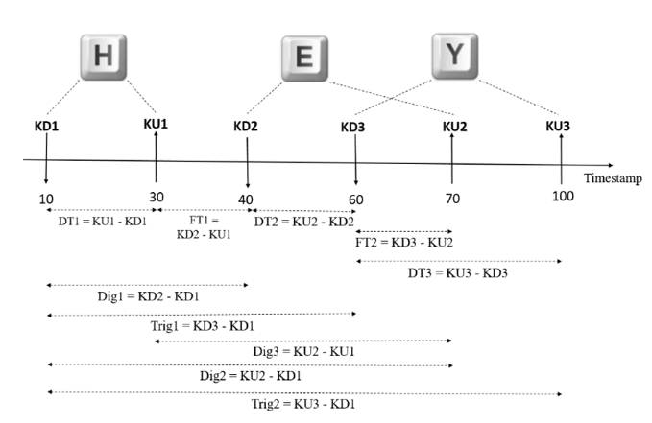
Figure 2.2 A diagram of the calculations for getting the timings Maalej et al used in their experiment (Maalej et al, 2022).

The calculations Maalej used for their paper can be seen in Figure 2.2. As you can see, IKIs are calculated using time stamps of when keys are initially pressed and released. Maalej used a combination of these to get granulated levels for their data, but other papers have simply measured for first key down to second key down or similar for releases and still found success. A problem highlighted by Figure 2.2 is that during typing, the next key may be pressed before the last is released in complex calculations, which could lead to a negative time, which could ruin any calculation in which it is used. Due to this, the project will use IKI’s calculations using to same-to-same calculations. With Maalej’s IKI data, it was found that AI models trained on this data had great success, with accuracy ranging from low 90s to mid-60s in percentages. With SVM and ANN being the top scorers with 90+% across all states (Maalej et al, 2022).

The most relevant application to this project is in detecting elevated mental stress. Stress is a more general state when compared to a specific emotion. So, it is simpler to verify its cause and growth. A paper that this project found most useful was written by Yee Mei Lim et al. Within this paper, Lim explored the effect that increasing cognitive stress has on human-computer interactions and task efficiency. This included KDs, mouse use, error rate and completion time. These were then measured against the participants' perceived level of stress on a Likert scale. The method Lim used to elicit this stress was a set of 10 mathematical equations which grew in complexity. The participants were required to solve the equations mentally, then type in their answer, some with a time limit, the others without. Data from 60 participants showed a slight but significant correlation between mental stress and the forms of user interaction. However, there was a mix of positive and negative correlations. Specifically, it was found that when the difficulty of the question increased, task duration, task error and stress perception increased while keystroke speed and mouse speed decreased (Lim et al, 2014). To further reinforce that it was the difficulty of the question, a univariate test was performed and found “the main factor that affects all three behaviours is mainly the task itself (Question, in our experiment).” (Lim et al, 2014). This logically makes sense; a complex problem causes an increase in mental stress. Leading a person to utilise more cognitive power may slow any motor movement, including the act of typing. Mental stress is a universal reaction, not limited to mental arithmetic. This Project posits that as long as the task is sufficiently challenging, lengthening of pauses would mirror Lim’s results no matter the task. With all these findings in mind, this Project believes that KDs is the best nonintrusive adaptation trigger for this project's proposed system.

2.3 Coloured Noise
As for the actual change that will occur when high stress is detected, it will need to be unobtrusive so as not to distract the office worker. To that end, an interesting and well-researched option is Coloured Noise. The term coloured noise refers to bands of frequencies at certain strengths across the range of frequencies detectable by humans. The name is analogous to light, just like light, a given range of wavelengths produces a certain colour, so too do certain bands of frequencies and power give a colour of noise.
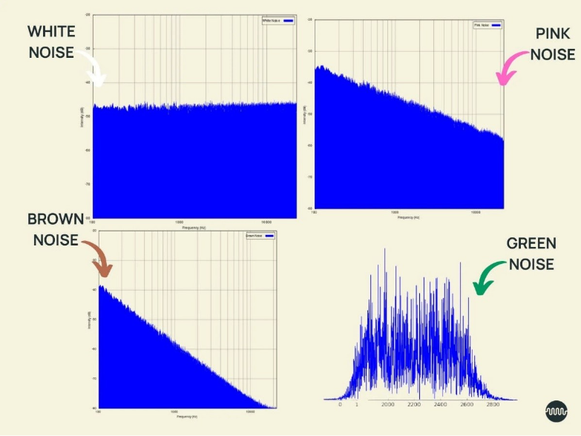
Figure 2.3 A diagram of various coloured noises and their frequency ranges (Soundly.com, 2025)

As shown in Figure 2.3, white noise has roughly equal intensity at all frequencies, sounding like TV static or a waterfall. Pink noise decreases in intensity as frequency grows, sounding like rustling leaves or ocean waves. Brown noise is similar to pink with decreasing intensity, but has a lower intensity overall, giving a deep rumbling sound. Of the several accepted coloured noises, only White, Pink and Red/Brown noise have been tested scientifically for their effects on human cognition. They all produce similar types of improvements in focus, recall and cognitive performance (Helps et al., 2014). However, these improvements are best seen in individuals with attention disorders, with the improvements being moderate to low in neurotypical individuals. The main theory for this finding is that coloured noises cause “Stochastic Resonance”. This is a phenomenon where constant noise affects the neural signals of the brain. The energy of the noise boosts the neural signals, giving the signals the energy to get over the detection threshold, allowing more signals to be fired overall. This induces what is commonly known as a “flow state”, where thought and action are seamless and cognitive performance is at its best. However, there is an inverted U-shaped pattern to this interaction. If the resonance is too little, the neural signal won't fire and too much resonance causes too many signals to be fired, causing confusion (Helps et al, 2014). The “sweet spot” where stochastic resonance was found to occur by many papers was between 40 - 60 decibels.

There are some concerns however, stochastic resonance is best for those with attention deficits due to the strength of their neural signals being low. The added energy supports the useful thoughts making them occur easier but with neuro-typical people the useful thoughts already have the strength they need to be detected. At that point, the coloured noise is more of a distraction than a support. There is also an aspect of individual preference as to whether a person finds the colour of noise comforting or irritating. If the person finds the noise irritating, the decibel level of the noise is irrelevant; any potential support is lost immediately. With this finding in mind this Project suggests that despite the lower effect on typical people, coloured noise could still be a useful method of support. At the very least, it could mask background noise if the user is struggling and refocus them on a task.

2.4 Collecting user experience
In order to answer the research question proposed by this project, it is necessary to be able to accurately gauge perceived usability and user experience of the system. Gauging subjective experiences through surveys is very complex and key aspects can be missed. Considering this fact, this project will use pre-made, validated surveys to collect the experience data. In the case of usability, the SUS survey is an industry standard for all kinds of software systems. It uses a 5-point Likert scale to represent differing levels of disagreement to agreement with statements (Brooke, 1996). The results are calculated as a percentile, with 100-90 being “Very Good” and each descending bracket being worse performing, with anything under 50 considered a failure. Due to its industry use, it has been validated and is almost expected to be used when evaluating a system. As for evaluating user experience, many surveys and questionnaires could suit this project's purposes. To help narrow down the options, Ignacio Díaz-Oreiro et al performed a literature review on which user experience surveys were used to evaluate the user experience of the systems made during experimentation. The three main surveys found by Díaz-Oreiro were AttackDiff, UEQ, and meCUE. The first two are based on the work of Hassenzahl and measure the users' perceived hedonistic and pragmatic qualities of the system (Hassenzahl, 2001). By interrogating the participants' views on the systems' Attractiveness, Perspicuity, Efficiency, Dependability, Stimulation and Novelty. The last is based on the work of Thüring and Mahlke. They gauge the user experience through analysis of how the user views the system's instrumental (functional aspects), non-instrumental (aesthetic aspects) and the user's emotional reaction to the system (Thüring, 2007). Díaz-Oreiro et al found 946 papers using one of these surveys, of which AttackDiff was the most used. However, it was found that “UEQ is growing at a faster pace, surpassing AttrakDiff in 2017 and 2018 by 42% and 47% of uses, respectively.” (Diaz-Oreiro 2021) due to this, the project will mirror this trend and utilise UEQ, which is becoming the most trustworthy of the three.

2.5 Summary
The aim of this project is to evaluate an adaptive system utilising coloured noise as an office support tool. Based on the findings of this literature review, the AUI system this project proposes will include KDs as the method of when to implement the adaptation due to its ability to be used in real time and its simplicity of implementation. Specially the KD metrics that will be used focus on evaluating stress. The actual adaptation that the AUI will implement is coloured noise. The noise will be limited to 40 decibels to reduce the chance of overstimulation and to give the best chance of supporting differing types of people. To ensure the user experience of the system is properly identified, SUS and UEQ will be used.

Chapter 3 Methodology
This chapter will discuss the processes and technologies used to develop the office work support tool and how usability and user experience were measured. PsychoPy was used to develop the AUI and the experiment around it. It allows for building further functionality through code components written in Python or JavaScript. To avoid tangents during the methodology breakdown, programs and libraries with their functions will be discussed here before the granular details. A high-level view of what the participant's required actions are provided. While being exposed to various types of coloured noise a constant background noise as a control, and an adapting background noise as the experimental condition, participants completed two recall tasks and filled out a few surveys about their experience with the system.

3.1 Development methodology
Based on the features of the project, a Waterfall development approach was chosen. As the final system had few requirements with specific functionality the turnaround for steps was quick. As such, bug fixing and fine tuning was implemented and tested very quickly. This strict step by step approach ensured that the system and the surrounding experiment was always within requirements with functionality acting as intended. The experiment was built in PsychoPy which has drag and drop GUI creation and functionality is implemented through simple programming. Clear instructions and goals which is core to the waterfall development approach is vital to the system and experiment being able to answer the research questions of this project. To ensure smooth progression of the project a Gantt chart was created to provide a clear overview of tasks. Their deadlines, importance and the dependents of the tasks were taken into consideration as well as some leeway encase of setbacks. (see Appendix A).

3.2 PsychoPy and Python Libraries
PsychoPy is open-source software that has the main goal of facilitating the creation of psychology-based experiments. The software is Python based but can be run in JavaScript for online experiments. In fact, for ease of use there is an auto conversion feature to allow for easy conversion between the languages. This project utilised PsychoPy mainly due to its built-in tools for experimentation and data collection. Primary among them is the counterbalancing component for selected variables. This component uses the Latin square method to ensure that each condition of the experiment is addressed equally removing bias and removing the effects of ordering improving validity of findings. The second important feature used by this project is PsychoPy’s ability to capture data in real time. PsychoPy has custom clock functionality built into its core components. The clock reads down to the sub-millisecond level perfect for reading KDs. Another useful core function is that PsychoPy records any interaction the participant makes with the experiment. Such as using keyboard/mouse, eye tracking, what button was clicked and how often, among many different options. By combining these two core features this project can create a system that knows when and which key was pressed, the timing between presses, how many of a particular button was pressed and what the previously pressed key was. All data that can be used to calculate KDs metrics.

3.2.1 NumPy
The NumPy library adds functions that allow for the ability to perform calculations on large multidimensional arrays. It was primarily used in this Project to calculate the percentiles of the users IKIs for later use in the pause checking functionality.

3.2.2 Json
The Json library allows for data to be stored and exported in the Json file format. Within the experiment the library was used to store the timings of button presses, the timings of the active triggers and the time spent in the altered state. Due to potentially extended nature of the write up section the lists holding the timings can grow very large and potentially crash the experiment losing any data. So instead, the library is utilised to write a Json file during the experiment so no data is lost and the experiment can run smoothly.

3.3 Experiment Environment
The experiment was held in person for various reasons primary among them having control of the environment. While PsychoPy does allow for online distribution the specific noise range needed for stochastic resonance to occur is extremely hard to enforce remotely. Speakers and headphones have a wide range of max decibel output so asking an online participant to set their devises sound output to a specific level doesn’t guarantee correct implementation. Holding the experiment in person allowed for external noise to be negated creating a neutral environment. To achieve this the experiment was held in a quiet room with windows and doors closed to ensure external sound was eliminated. A decibel meter was used multiple times to ensure the coloured noise was around 45 decibels at the lower end of the inverted U. This was to ensure the participants were comfortable listening for a prolonged period. The lead researcher accompanied the participants initially while they read the consent info and instructions and was available to answer any questions. The lead researcher then left the room while the participant completed the experiment; however, the lead researcher was nearby in case problems arose.

The requirements for participation where basic IT literacy skills, familiarity with Office programs such as Microsoft’s office suite and the ability to use a keyboard. The participants were a mix of university students and office workers. There was a wide range of ages, a mix of genders and nationalities. The participants totalled 30 split evenly between a control group and the group with the AUI.

3.4 Experiment Structure
The experiment follows a between subject’s design specifically AB testing. One group acted as a control (which has a baseline background noise consisting of white noise) and completed the tasks as normal. The second group completed the same tasks but using the adaptive system (coloured background noise being varied according to KDs, including white noise among others). PsychoPy’s counterbalancing component was used to randomly assign participants to the groups. A between subjects design, specifically AB testing, was chosen due to the need to have a baseline to check the adaptive systems user data against, and avoidance of carryover effects since the tasks need to be the same to be able to compare data. In whichever sequence the Latin square put them in AB or BA the participants will be familiar with the type of task even if the content is changed which will skew results when comparing the control group vs the adaptive group. Due to the partisipant having previous experience proforming this type of task potentially preforming better than base line on the second round of the task.
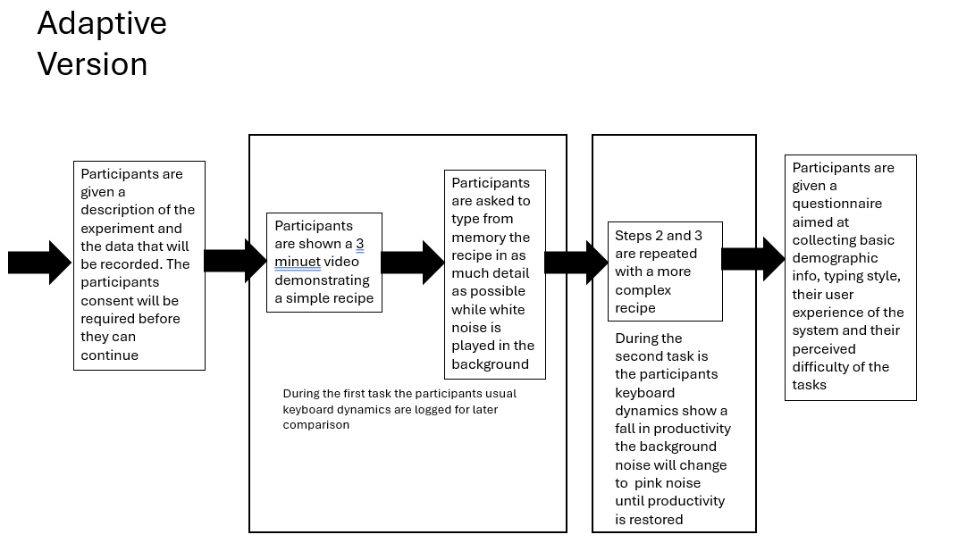
Figure 3.1 A diagram of the overall flow of the experiment

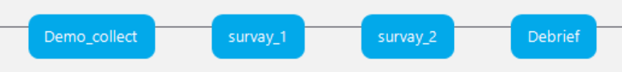
Figure 3.2 screen shots of the finalised timeline of the experiment

As shown above in Figures 3.1 and 3.2 the timeline of the experiment is linear and flows into the next. After the consent and instruction pages the participant starts the main part of the experiment. The participant completes a set of two of the same type of task the first is simple meant as a primer for the type of task the participant will complete, but it also is a vital data collector for the adaptive group collecting their baseline KD data. The second more complex task has the adaptive system implemented this is where the KDs data that will be investigate is collected. The tasks consist of watching a recipe video and then typing all the details the participant can remember. This task was chosen due to its nature closely mimicking that of standard office work. It requires the user to take in varied types of data textual, visual and audio, then filter them down to the most vital information and report it, just like summarising sales reports or composing emails. The specific cognitive abilities needed for the task are clearly defined as attention, working memory and comprehension. These aspects can be measured simply by analysing time to complete tasks and the number of mistakes made. The difficulty of the task can be easily assigned by the difficulty of the recipe. By using a quick recipe everyone knows or could follow the task easier and is completed faster with no mistakes. With a more complex ethnic recipe the task becomes harder and key details are likely to be missed. Due to this the primer task is a recipe for pancakes it is very simple with few ingredients and is well known enough to have holiday based on them. The complex recipe is an ethnic recipe called Khachapuri or Georgian cheese bread. This recipe was chosen due to the likelihood that participants would not be familiar with it, meaning all participants should be on at the same level when stating the task. The difficulty of the recipe comes from the unusual ingredients and the methods for shaping the dough. This should increase mental stress and cause the KD check to trigger the adaptation.

As previously discussed, the experiment used the SUS survey and the UEQ questionnaire. But in addition, some surface level demographic questions were added to aid in the analysis of specific groups. Also questions from the Perceived Difficulty Assessment Questionnaire (PDAQ) were used to determine the participants perceived level of difficulty of the experiment. The PDAQ was a short question sheet developed by Nuno Ribeiro of the Pennsylvania State University designed to gauge student interpretations on the difficulty of an assignment (Ribeiro, 2010).

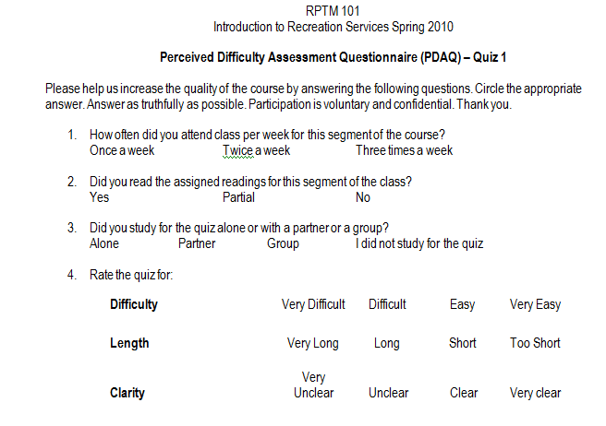
Figure 3.3 example of a PDAQ taken form the PDAQ workshop PowerPoint (http://www.site.psu.edu/pdf/PDAQ_workshop_09302010.pdf)

The above Figure show an example of the PDAQ that was used to test around 120 students about their experience. It was found the questionnaire had moderate predictive power but of most interest to this Project was that the PDAQ showed a clear breakdown of general perceived difficulty of the assignment. It was because of this that the difficulty and length questions were used in the experiment. In addition, a question based on how much experience the participant had cooking meals. This was because participants familiar with following recipes would have an easier time with summarising the instructions. This could sway results or be an explanation for said results.

3.5 Programmed Elements
All coded elements of the experiment were implemented to either collect/ store KDs data or the triggering of the AUI. This section will focus on each piece of code as they appear chronologically, as well as justifying the use of the elements they interact with. Of note is that code elements in PsychoPy are split into sections based on when they run. There are 5 sections before experiment normally used to import elements, begin experiment is used primarily to initialise variables used across the whole experiment. Begin routine is where elements or variables specific to the page are initialized. Each frame code here runs constantly, checking for user inputs/changing elements in real time. End routine runs when the current page finishes, it is used to collate data collected on that page. The last section is end experiment it is used to reset the elements before the next run of the experiment. This project specifically used begin routine, each frame and end routine. Specifically begin routine initialized the variables used in each frame and end routine. So, the code discussed below is within the latter two sections.

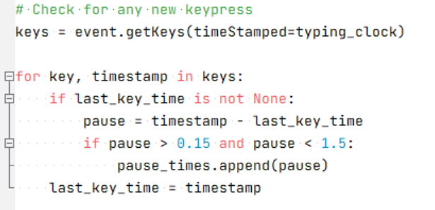
Figure 3.4 snippet of code used to collect IKIs of participants

The above code in Figure 3.4 was used in each frame section of the write up page of the simple task. This code simply collects the participants IKIs for calculation in the next code segment. This code segment starts by collecting all the participants’ key presses using PsychoPy’s core getKeys function. The specific time the key was pressed by using the core clock function. The clock was created in the begin routine section; because of this the timings are relative to the start of the page. This simplifies calculating the pause length to former minus the latter. Next a for loop enumerates through each of the key presses, however, first there is a check within the look to see if last_key_time is initialized with a valid value. If last_key_time is not assigned a valid value, it causes a crash due to a variable being missing from the calculation on the next line. last_key_time is initialized the same way as the clock to match the start of the page so it should always be 0. The next line calculates the pause time by taking the time stamp of the current key minus the time stamp of the last key in the list. Next there is a check to see if the length of the pause is between 15 milliseconds and 1 and a half seconds. The common IKI lengths measured by other papers are “between 0.5–1.0 s, 1.0–1.5 s, 1.5–2.0 s, 2.0–3.0 s, and > 3.0 s” (Conijn et al, 2019), with a trend towards the lower end and sub 0.5 seconds. The reason this project chose this specific time gap was to collect the participants average IKIs. So, pauses over 1.5 seconds could skew the average too heavily and cause inaccuracies in the adaptation triggers. If the pause is within parameters, it is added to list for use in the next section of code. Finally last_key_time is updated whit the lates key timestamp to repeat the process again. Since this code is runs on every frame as new key are pressed by the user, they are added to the event list and screened almost as the occur.

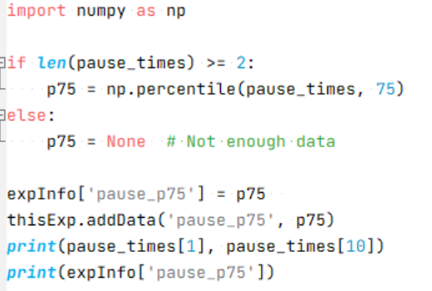
Figure 3.5 snippet of code used to calculate the 75th percentile of the partisipant

The above code snippet is run when write up page of the simple task ends. Its purpose is to take the IKIs that made it through the length checks and calculate the 75th percentile of the pauses. This is an important part of the AUI trigger system integrated into the complex task.
The pause_times list is first checked to see if the list has at least 2 items enough to make the calculation, this is to avoid crashes if pause_times is less than 2 items it will be set to none. This is highly unlikely to happen as writing a single word already ensures there is enough data. If there is enough data NumPy’s .percentile() function is called using pause_time and is set to find the 75th percentile. The percentile is then stored for later use by the trigger system and added to the data recorded at the end of the experiment. As previously stated, the simple task on top of acting as a primer task it collects vital data needed to find the upper bounds of the participants average IKIs.

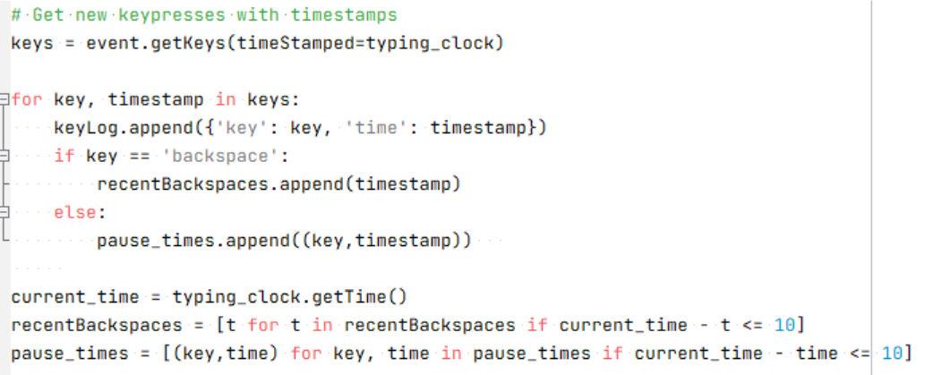
Figure 3.6 snippet of code used to collect KDs metrics of participants

All of the following snippets of code are the AUI system, and the data collected during its running. All but the last are together in the each frame section of the text write up page of the complex task. They have been split for ease of description, but the full code can be seen in Appendix B, the code starts by collecting the participant’s key presses using the same method described before. This time however the keys and their timestamps are added to a master log keyLog. This master log holds all interactions the participants make with the keyboard which would be used in later analysis. After this the keys and their timestamps are split based on whether the key was backspace. If the key is backspace its timestamp is added to recentBackspaces. If not the key and its time stamp is added to a new pause_times. Just after the loop assigning the keys data the current time is found and then used to prune recentBackspaces and pause_times, this is done by taking the current time and subtracting the timestamp of the key. The calculated time then checked to see if the time is less than ten seconds removing any that are longer.

This effectively creates a moving window covering the last ten seconds of KDs. The reason for implementing this moving window is due to the need of the system to work in real time. Most papers researching KDs tend to collect KDs after the text is finished or over a specified number of keyboard events (Kasprowski et al, 2022). Using a specified number of keyboard events could have been implemented but occurrences of high stress could be missed. A moving window ensures each KDs event is captured. As for why the window was set to 10 seconds, it was to avoid the adaptation triggering for too long or when it is not needed. The proposed system is intended to trigger only when the user is in a high stress state. A larger window allows for the adaptation to last longer but it also means older KDs keep the adaptation going longer than is needed. This Project deemed ten seconds to be long enough to meet the conditions to trigger the adaptation but short enough to not cause the trigger to be constantly active.

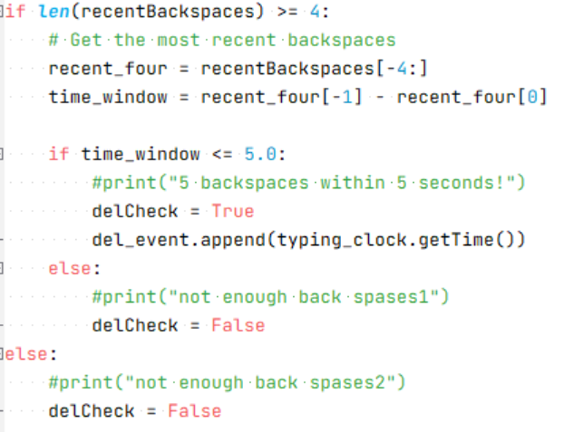
Figure 3.7 snippet of code that shows the conditions to activate the delCheck flag.

Once the keyboard events are collected and pruned, they enter the conditions and checks that make up the AUI. The AUI is deceptively simple consisting of three checks on KDs metrics before the AUI can trigger. Those being revision events, where a pause is taking place and higher than normal IKI occurring more frequently. The first shown above in Figure 3.7 is a check to see how many times the backspace key was used. This was done by first using an if else statement to check whether the length of recentBackspaces is grater or equal to 4. If it is, the program moves on to a further calculation that may lead to delCheck being set to true. If recentBackspaces is less than or equal to 4 delCheck is automatically set to False. The reason 4 was chosen for the limit of recentBackspaces before further checks can be made is that the majority of verbs and adjective are over 4 letters long. So, there is a higher possibility of a full word being deleted over fixing a typo. This Project believe that if the limit was lower there would be a higher rate of false positives causing inaccuracy. If recentBackspaces meets the requirements the latest 4 timestamps in recentBackspaces are taken and stored in recent_four. Then time between the oldest and newest timestamp in recent for is calculated through subtraction. The calculated time is then checked to see is it is less than or equal to 5 seconds. If it is, delCheck is set to true and the timestamp of the activation is stored in del_event. If it is not delCheck is set to False. This Project deemed 5 seconds to be an acceptable range with in a 10 second window. This does however highlight an issue with PsychoPy as this code is running every frame it cannot determine specific times the delCheck flag is set to true unless each instant is detached. As such when it comes to analysis the KDs metrics will be converted into a percentage duration against the total duration of the task. The same will be applied to the duration of when the coloured noise is playing.

Deletions and revisions are a core part of typing at any skill level. In fact, according to Laura Allen of the university of Arizona State (Allen, 2019) heavy use of backspace overall is a sign of highly skilled writers because skilled writers make finer grained revisions in their texts until they are satisfied. At the real time level this Project is exploring indicators of cognitive load as specifically represented by a pause followed by multiple revisions followed by typing new characters to replace old characters, e.g. rewriting a word or sentence, also known as a revision event. (Conijn, 2021). The code implementation for this metric was simply a check for multiple concurrent deletions that activates the delCheck flag. As alluded to earlier, if this metric alone could activate the adaptation, it would trigger at every minor mistake, so it was combined with the other two metrics.

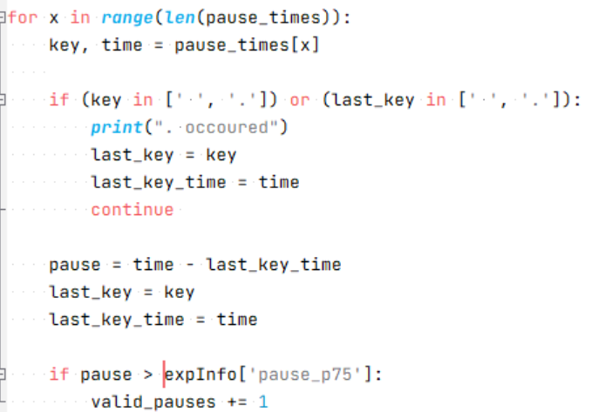
Figure 3.8 snippet of code that shows the calculations that are used to determine how many valid pauses have occurred.

It is here in the next section of code the other two KDs metrics are checked. The main body of the check is a for loop iterating through all of the key presses in the window. Both the key and its time stamp are important for both the remaining checks. The next check occurs immediately and is focused on where the pause is happening within the text. Although pauses are a part of inter-keystroke intervals, there is nuance with respect to where the user is pausing. Using pauses to plan ahead or revise are common. Even experienced typists take pauses to think before continuing. As stated by Conijn “Pauses at sentence boundaries are considered to reflect global text planning and require more time, compared to pauses at word boundaries” (Conijn, 2019). Conijn goes on to explain that pauses between words reflect the same planning but on a lower scale. (Conijn, 2019) Pauses like these are less linked to mental stress cause by a task but is representative of forward planning to complete the task. It is specifically longer pauses within words that are representative of higher mental stress. It is because of this that the if statement checks whether the current key or the last key checked in pause_times is either a space or a full stop. If either are found to meet the conditions the latest key and its time stamp are stored in last_key and last_key_time respectively, then the continue command is used to skip the rest of this iteration of the loop. By doing this any pauses between words or and the end of sentences are skipped. This focuses checks to be on pauses most related to mental stress.

If the key passes the location of pause check the pause between the current key and the last is calculated. Then last_key and last_key_time are updated before continuing to the main pause check. Here the calculated pause is checked against the participant’s 75th percentile of their IKIs. If the current calculated pause is greater than the 75th percentile valid_pauses is increased by one, then the loop starts again. As touched on in chapter 2 the relation between IKIs and cognitive load is straightforward: as cognitive load increases so too do IKIs (Conijn et al,2019). Longer IKIs are thought to be indicators of the user thinking or planning on what to write next, whereas shorter IKIs are thought of as evidence of rapid motor function or being “in the zone”. These findings are verified by Yei Mei Lim (2014) in their paper discussed earlier. They found a positive correlation between the difficulty of the question being asked and the length of IKIs. However, a point of interest was found by Conijn et al. (2019) when they compared an academic dataset (it was collected in a controlled setting for researching effectiveness of typing English as a second language) and Villani keystroke dataset (collected in a controlled setting for the purposes of testing KDs as a form of authentication). Both datasets contained a copy task and a more difficult secondary task; the academic dataset had an academic summary task, but the Villani dataset had an email writing task. The specific features Conijn analysed were number of keystrokes, deletes and the number of IKIs between 0.5 and 1 second. Conijn et al (2019) found that the total number of keystrokes, deletions and inter keystroke-intervals for the academic tasks were different, but not for the Villani task. Conijn et al posited that “the academic summary task could be considered more complex compared to the email writing task” (Conijn, 2019), suggesting that IKIs only differ if the cognitive load of the tasks are sufficiently varied. Despite these findings this Project is confident that inter-keystroke intervals measured in this experiment will closely mirror the findings in Conijns academic dataset analysis, due to the difficulty of the task proposed by this project matching the higher level of difficulty seen in the academic dataset's academic summary task.

It was because of these findings that the Project decided to use IKI filtered through the location of the pause. As for why the participants 75th percentile was used over a set amount was due to KD being unique to the user there was an elevated chance for incorrect triggering. With the check linked to their above average IKIs this Project believes that the AUI will react will more accuracy to the participants KD.

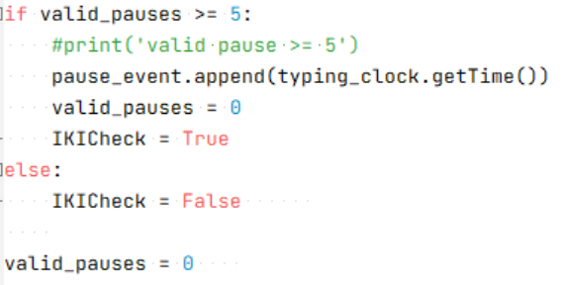
Figure 3.9 snippet of code that shows the check used to activate the IKICheck flag.

Figure 3.9 shows the if statement used to trigger the IKICheck flag. It simply checks whether valid_pauses is greater or equal to 5 AKA whether 5 or more pauses within the window are above the participant’s 75th percentile of IKIs. If the if statement is correct IKICheck is set to true, the timing of the true IKICheck is active is saved in pause_event and valid_pauses is reset to zero. If the statement is incorrect IKICheck is set to false, then after that valid_pauses is reset to zero regardless of the outcome of the if statement to ensure a fresh start when the program is run for the next frame. The reason 5 or more pauses activates the IKICheck flag was due to participants who screened the experiment before launch. It was found that their 75th percentile was found to be between 0.4 and 1,2 seconds. Due to the window being 10 seconds, it was deemed 5 or more pauses avoided single instances of hesitation while still being achievable naturally through KD while under heightened mental stress.

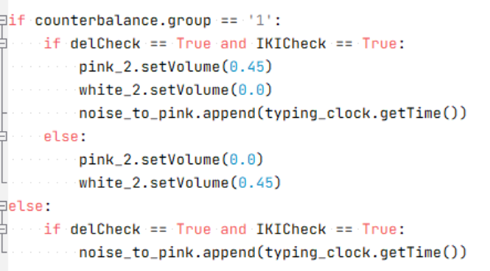
Figure 3.10 snippet of code that activates the AUI change.

The above Figure shows the triggering mechanism for the systems AUI. First and outer if statement checks which group the counterbalancing component assigned the participant too. If they are a part of the adaptive group, it moves into the system when the adaptation takes place. If the participant is in the control group, the system doesn’t change but the time the adaptation would have been active is recorded for later analysis. The adaptation will only trigger if both delCheck and IKICheck are both true. This project believes that with this system, using the metrics discussed we will be able to accurately detect increases in a user's cognitive load when collated and trigger the adaptation appropriately. If the participant is using the AUI system, if both triggers are true the baseline coloured noise of white is silenced and the background noise of pink noise has is volume raised. The timing of the change is also recorded in noise_to_pink. If or when one of the flags becomes false, the pink noise is silenced, and the baseline of white nose is reinstated.

The reason this project decided to use white and pink noise despite both inducing the same effects is that some papers which experimented with white and pink noise found that while both improved cognitive performance, improvement from pink noise was slightly but significantly better than white noise (Lu et al, 2020). If white noise is used as a base for both the adaptive and non-adaptive experiments, there should theoretically be a slight but significant difference when the change is made to pink noise. Issues could be raised with white noise compounding any of the benefits bestowed by changing to pink noise; instead, simulated office background noise should be used to offer the best chance to see a clear difference. While this project is attempting to simulate realistic office environments and tasks, the unpredictable nature of when the adaptations occur would make it difficult to compare experimental conditions; as such a continuous constant background noise should clearly show any differences however small.

However, a long-understood phenomenon known as controllable vs non-controllable stress shows that when given a non-controllable stressor such as a noisy office space stress levels will likely rise, but as Joseph S. Blythe puts it “control over a stressor may decrease stress caused by the stressor” (Blythe et al, 2023). As white and pink noise are distinguishable, it is conceivable that participants will understand the method of control and may develop a perception of control, improving work efficiency and overall user experience, as shown in works as far back as David Glass’s work on the subject (Glass et al, 1971). Therefore, there should theoretically be a similar effect had the project used simulated office noise.

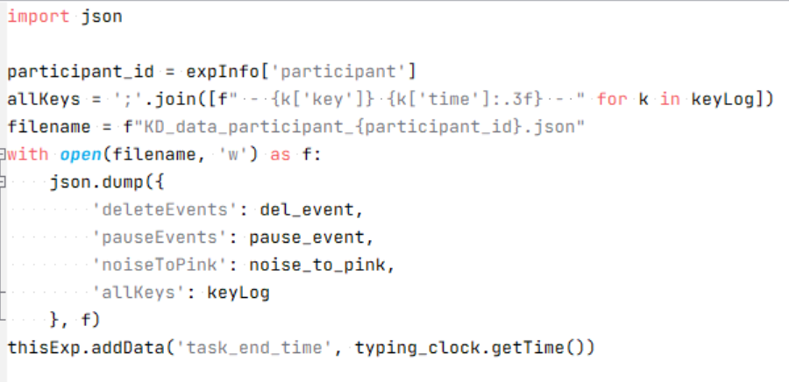
Figure 3.11 snippet of code that collates all of the recorded data in Json format.

The final piece of code shown in Figure 3.11 collates all of the timings of the various flags and adaptations. This is done by first getting the randomly assigned ID of the participant. Next all of the key and timestamps in keyLog are formatted into “{"key": "k", "time": 298.66360910000003}” for later analysis. Next the name for the folder holding the data is created partly using the collected participant id and it is stored in filename. Next the “with open” command creates a file named using the variable filename and the use of ‘w’ means data can be written into it. That data is written using the .dump() function from the Json library, it formats the selected data into the Json format, in this instance said data is the lists for del_event, pause_event, noise_to_pink and keyLog. This data was stored in an external Json file due to the fact these lists can grow quite large as hundreds of keys can be pressed even in just a few minutes. This amount of data can cause bottlenecks as PsychoPy parses the data when the experiment ends, this could potentially cause a loss of data or corruption, saving the data early when the complex task finishes ensures data security while streamlining experiment to experiment. Finally the time the participant took to complete the task is captured for use in later analysis.

3.6 Keyboard Dynamics Analysis method
While KD analysis of IKIs among other metrics are useful for finding overall competency and experience while typing it can be further analysed to discover any underlining patterns. The method this project used was recurrence quantification analysis (RQA). RQA finds recurrence of patterns within a time series by comparing said time series with itself with a small time delay. This creates what is known as a “Phase Space” and within phase space the underlying relationships between contributing factors can be found, by measuring the recuring stats frequency and durations. This analysis results in a graph like the one shown in Figure 3.12 along with various metrics. Fortunately, Lisa Haake used RQA on KD metrics specifically IKIs to find differences when a person is typing in their first language vs their second. Haake found that the KD metrics were far more structured with fewer brakes and a higher flow when participants wrote in their first language (Haake et al., 2022).
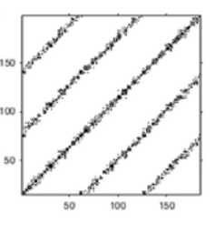
Figure 3.12 RQA plot showing the recurrence of a sine wave (Wallot, 2017)

This Project theorises that the results of its experiment will mirror Haake’s findings in that the pink noise will induce a flow state that will show as higher structured recurrences. RQA analysis does require careful tuning of testing parameters to properly highlight recurrences. However, due to time pressure this could not be done for all participants. To mitigate any potential loss of data this Project used the tuning metrics highlighted in Haake’s paper. This was due to Haake also working with IKIs when working with their RQA. Following Haake’s well tested tuning values will be applicable to this Project. Also, by keeping the tuning values consistent across all RQA’s it will add validity to any findings. The specific RQA metrics that were analysed were Recurrence Rate (RR), Determinism (DET), Average Diagonal Line Length (Lmean), Entropy (ENTR), Laminarity (LAM) and Trapping time (TT). RR is a measure of the density of recurrences; a high RR indicates a more consistent system. DET is the proportion of recurrences forming the diagonal line seen in Figure 3.12. A high DET signifies that the time series is predictable for when its patterns occur. Lmean is a measure of the average length of those diagonal lines showing that each pattern lasts a certain amount of time. ENTR measures complexity of how the diagonal lines are distributed, a high ENTR means the system is less predictable with its patterns. LAM is the proportion of recurrence points forming vertical lines. Vertical lines indicate points where the system is unchanged hence more LAM the more stable the system is. Lastly TT is the average length of these vertical lines indicating how long these periods of stability last. All of these metrics were calculated using the PyRQA Python library specifically the RQAComputation.create() function. The other metrics analysed are far rougher and cruder, but they were still useful as they encompassed the participant’s accuracy in the task as well as their experience with the system.

As stated in chapter 3.5 due to PsychoPy running the same program each frame it is hard to determine a specific count of individual triggering of KD events. As such the KD metrics will be calculated as a percentage of the time the event was active against the total time of the task. This way the data was still comparable.

The final piece of KD analysis was on the recipes the participant wrote up. To find how accurate the participant’s recipe was to the original the Levenshtein edit distance formula was used. Levenshtein edit distance formula is a calculation that counts how many single character edits is needed to change one piece of text into another I.E. how many edits deletions or insertions. The higher the edit distance the larger the difference between the two texts. There is another metric called Levenshtein ratio; it is a measure of how similar the two texts are on a scale of 0 to 1, both will be investigated. To lower the need for further editing the overall layout of the original recipe was transposed into the text boxes the participants completed.

3.7 Surveys Analysis
Both the SUS and UEQ surveys have specific encoding and calculations to get the final score. These scores also have a specific meanings and associations. The perceived difficulty and cooking experience questions follow their own simpler encoding as well. As previously stated, SUS operates on a 5-point Likert scale. Across the 10 questions of the survey each ask the participants how much they agree or disagree with a statement. The questions alternate between positive and negative statements. With odd numbered questions being positively phrased and even being negatively phrased. Due to this high agreement with odd number statements is considered a good thing but the same with even numbers of statements are not. To collate all of the responses into a single score reverse encoding is needed, and this is done through a calculation for each type of statement.

For odd questions the score is the scale position minus 1. For even questions the score is 5 minus the scale position. Then the sum of the scores is multiplied by 2.5 to obtain the overall value of SUS. As the overall score is a percentile a score of 68 would be around the 50th percentile. As such a good to great SUS score would be 70 upwards as can be seen in Figure 3.13. To get the final SUS scores for both groups all the individual scores were calculated then the average was taken for each group, for comparison during analysis.

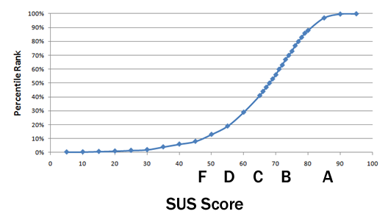
Figure 3.13 Graph showing SUS score against percentile (Measuringu.com, 2024)

UEQ has a higher complexity since it deals in specific hedonistic and pragmatic qualities of a system. The encoding however is quite simple with just two steps. First the 7-point Likert scale needs to be converted from 1 to 7 to -3 to 3. This is due to how the QUE is structured. An associated positive quality is placed on the right side of the scale. The corresponding negative quality is placed on the left. The participant is prompted to select at which point on the scale they found the experience of using the system between the two qualities. An example would be between “Boring and Exciting”. The participant selected 5 meaning they found the experience slightly exciting. The second step is to find the mean for each hedonistic quality questions and for each pragmatic quality questions. It is here where QUE differs from SUS, the resulting averages are compared against a set of ranges. Below -0.8 is seen as bad, scores between -0.8 and 0.8 as seen as average and 0.8 and above is good. A further level of granularity can be achieved due to the ability to see the breakdown of individual questions to see which aspects of the system stood out whether good or bad. The calculated averages can also be compared against a benchmark based on 468 systems tested with UEQ.

The creator of UEQ has streamlined the process of scoring by publicly publishing an Excel-based scoring tool on their website “https://www.ueq-online.org/.” (UEQ, 2018). The scoring tool takes the raw data and preforms all of the conversions/calculations and displays the results in the graphs shown below in Figure 3.14. Seeing how the scoring tool was developed by the creators this Project sees its use as acceptable. A point this project believes that should be highlighted is that the short 8 question version of the UEQ was used. The was due to the experiment being twenty plus minutes long before the survey section. There may be some nuance missed by not using the forty plus version however this Project sees that the core aspects are still surveyed by the short version.

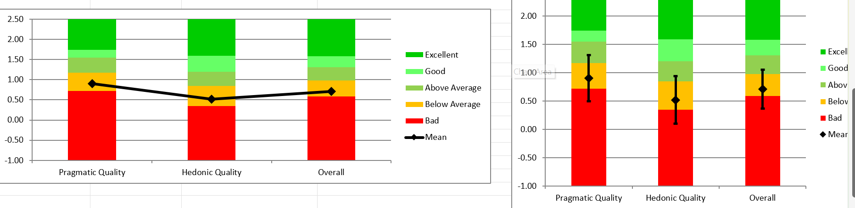
Figure 3.14 Graph from the UQE data analysis tool.

Lastly the questions on perceived difficulty and length of the task taken from the PDQA as well as the cooking experience question are simple and don’t require calculation. However, they do require encoding like SUS they use a 5-point Linkert scale with the most negative options on the left and progressing towards positive on the right. They also require transforming the option into 1 to 7 interpretation is simply the higher the better the participant found the experience. A high score on the cooking experience question means a high experience cooking and therefore they may have found the task easier to complete.

3.8 Significance Measures for results
As this experiment follows AB testing guidelines, all analyses will focus on finding a significant difference between the control group and the adaptive group. Jamovi 2.6 was used to perform all of the tests on all results (The Jamovi Project., 2021). The specific tests used to determine significance heavily depended on the specific types of data that were tested, so each test was performed on a case-by-case basis.

The results from the experiment were a mix of ratio/interval and ordinal data. Specifically, all the RQA metrics, all of the percentage totals for the active time the various KD flags were true, the percentage time the adaptation was active, the Levenshtein edit and ratio and time to complete the task are all considered either ratio or interval during significant distance analysis. Both types of data can use the same significance test, whereas, the responses to the perceived difficulty, length and experience cooking questions are ordinal and must use a different set of tests for accurate analysis. This distinction must be made as ratio/interval significance tests require the data to be normally distributed, whereas ordinal significance tests don’t require the data to have any specific distributions.

The test used to determine normality for all of the results was the Shapiro-Wilk test due to its built-in tolerances for smaller dataset sizes. The test found that the only results that didn’t have had normally distributed data for both the control and adaptive groups were the perceived difficulty and length of the task results. There were also results that had a mix of normal and non-normal distributions between groups, these included both the Levenshtein metrics, the percentage time the pause flag was active, the percentage time the AUI adapted to pink noise and the RQA metrics of DET, Lmean and LAM. This group of results were treated as ordinal type data moving forward. This was due to the previously mentioned fact that ordinal significance tests don’t require any specific distribution and they focus on the data ranks over the specific numbers, so the relationship the data represents is still accounted for. Based on this and the previous findings a Mann-Whitney U test was performed to discover any significant difference. The remaining metrics of the total time taken to complete the task, the percentage time the delete flag was active, both overall scores for the surveys and the RAQ metrics RR, ENTR and TT were found to have normal distributions for both the control and adaptive groups, as such these results were tested with an Independent samples T-test.

Chapter 4 Results

4.1 Keyboard Dynamics Results

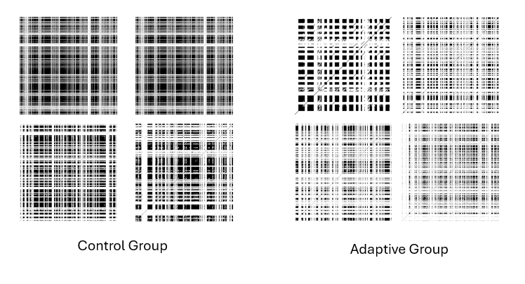
Figure 4.1 A Selection of RQA Plots taken from both the control and adaptive groups.

Figure 4.1 shows a selection of RQA plots taken from both groups. As can be seen the control groups plots have more dense blocks of points with high uniformity in the intersections of white lines suggesting high RR and DET, suggesting the control groups typing was slower and more deliberate. The adaptive group had far more white space signifying no recurrence point, suggesting their typing was highly varied and inconsistent with the expected flow state. This suggests the adaptive groups flow was easily broken. The plots for all participants can be seen in Appendix C.

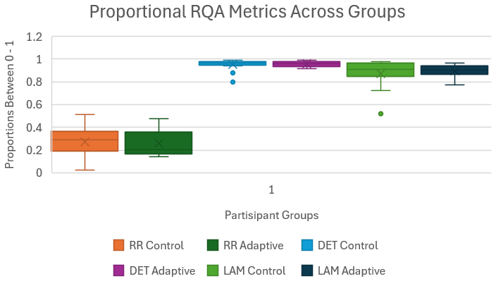
Figure 4.2 Box and whisker plot showing the difference in the proportional RQA metrics.

Figure 4.2 shows that the Proportional RQA metrics for both the control and adaptive are very similar with their results. Each metrics spreads are similar with all the whiskers for the adaptive group metrics being enclosed within the control group’s metrics. The only thing of note is that the box for the adaptive groups LAM being slimmer and more condensed than the control groups.

Figure 4.3 Box and whisker plots showing the difference in RQA average length of diagonal and vertical lines.
Figure 4.3 show the average length of the two types of lines considered in RQA plots. Again, the plots show no difference between the groups however the control groups Lmean is spread much more compactly while their TT has the largest. Suggesting their typing flow lasted longer.

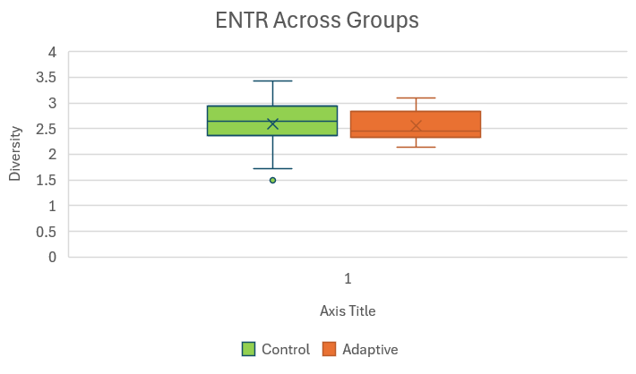
Figure 4.4 Box and whisker plot showing the difference in RQA entropy a measure of diversity of diagonal lines.

Figure 4.4 shows there is no difference in the ENTR of both groups, suggesting that the diversity of the recurrence patterns were similar.

An independent samples t-test was performed to evaluate whether there was a difference between RR, ENTR and TT for the control group and the adaptive group. The results indicated that there was no significant difference between the RR, ENTR and TT for the control group (M = 0.274, SD = 0.140) (M = 2.591, SD = 0.521) (M = 9.64, SD = 4.397) and the adaptive Group (M = 0.261, SD = 0.133) (M = 2.55, SD = 0.305) (M = 8.798, SD = 2.514)

A Mann-Whitney U test was performed to evaluate whether the control groups DET, Lmean or LAM differed from the adaptive groups DET, Lmean or LAM. The results indicated that there was no significant difference between the DET, Lmean or LAM of the control group and the adaptive Group. p = .345, p = .461 and p = .935 respectively.

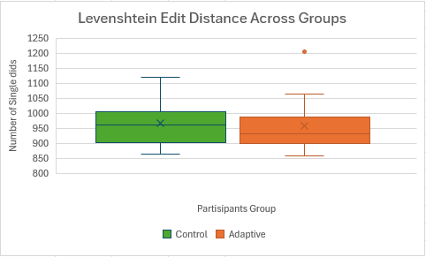
Figure 4.5 Box and whisker plot showing the difference in Levenshtein edit distance a measure of difference.

Figure 4.5 shows the difference between the control groups and adaptive groups Levenshtein edit distance. The adaptive group appears to have a more condensed and slightly lower spread of scores.

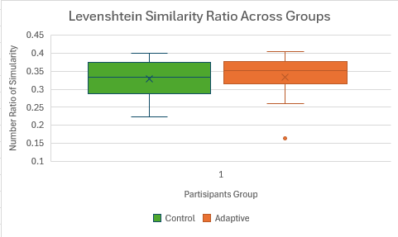
Figure 4.6 Box and whisker plot showing the difference in Levenshtein radio a measure of similarity.

Figure 4.6 shows the difference between the control groups and adaptive groups Levenshtein ratio. The adaptive group appears to have a more condensed and slightly higher spread of scores.

A Mann-Whitney U test was performed to evaluate whether the control group’s Levenshtein edit distance or ratio differed from the adaptive group’s Levenshtein edit distance or ratio. The results indicated that there was no significant difference between the Levenshtein edit distance or ratio of the control group and the adaptive Group. p = .604 and p = .633 respectively.

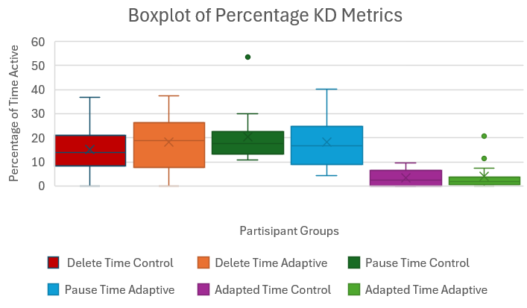
Figure 4.7 Box and whisker plot showing the difference in percentage time metrics scores.

Figure 4.7 shows the difference between the control groups and adaptive groups percentage times the delete flag and pause flag was active as well as the percentage time pink noise was the background sound. The control group appears to have more condensed spread of values for both delete time and pause time. The control groups delete time is slightly lower than the adaptive group, but the control groups pause time is slightly higher that the adaptive groups. Conversely, however the time pink noise was active for the adaptive group is lower than the control group.

A Mann-Whitney U test was performed to evaluate whether the control group’s percentage time for pause flags was active and the percentage time the AUI caused an adapted state differed from the adaptive group’s percentage time for active pause flags and in adapted state. The results indicated that there was no significant difference between the percentage time for pause flags and in the percentage time in an adapted state of the control group and the adaptive Group. p = .787 and p = 1.0 respectively.

An independent samples t-test was performed to evaluate whether there was a difference between the percentage time for the delete flag being active for the control group and the adaptive group. The results indicated that there was no significant difference between the percentage time for the delete flag being active in the control group (M = 15.09, SD = 9.53) and the adaptive group (M = 18.24, SD = 10.66)

4.2 SUS Survey Results
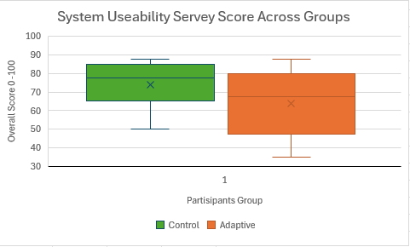
Figure 4.8 Box and whisker plot showing the difference in SUS survey scores.

Figure 4.8 shows the difference between the control groups and adaptive groups SUS score. The control group appears to have a more condensed and higher spread of scores.

An independent samples t-test was performed to evaluate whether there was a difference between overall SUS score of the control group and the adaptive group. The results indicated that there was no significant
difference between the Overall SUS score of the control group (M = 73.83, SD = 12.2) and the adaptive group (M = 63.67, SD = 16.5).

4.3 UEQ Survey Results
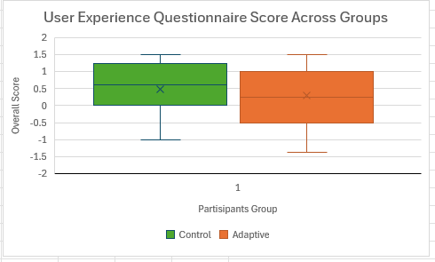
Figure 4.9 Box and whisker plot showing the difference in UEQ survey scores

Figure 4.9 shows the difference between the control groups and adaptive groups UEQ score. The control group appears to have a more condensed and higher spread of scores.

An independent samples t-test was performed to evaluate whether there was a difference between overall SUS score of the control group and the adaptive group. The results indicated that there was no significant difference between the Overall SUS score of the control group (M = .483, SD = .772) and the adaptive group (M = .292, SD = .875).

4.4 Perceived Difficulty Results
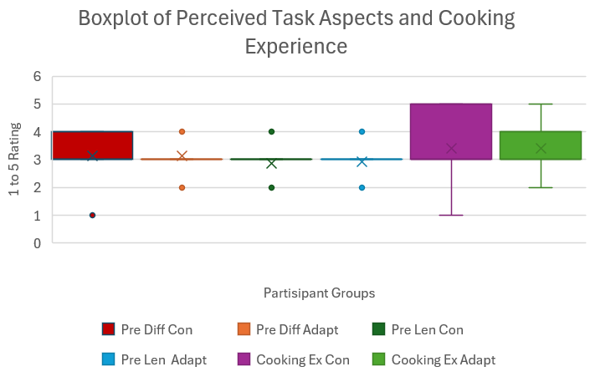
Figure 4.10 Box and whisker plot showing the difference in the perceived difficulty and length of the task alongside the cooking experience

Due to the perceived metrics and experience questions only having a range of 5, this spread does not have the space to properly plot the box and whisker into the proper shape. However, the majority of participants put 3 for each question as such there is little to no difference between the groups when plotted.

A Mann-Whitney U test was performed to evaluate whether the control groups perceived task difficulty, task length or cooking experience differed from the adaptive groups perceived task difficulty, task length or cooking experience. The results indicated that there was no significant difference between the perceived task difficulty, task length or cooking experience of the control group and the adaptive Group. p = .757, p = .777 and p = .965 respectively.

Chapter 5 Discussion
Given that no significant findings were found, the discussion of this Project will instead critically review the methodology of this novel approach. The experiment will be treated as a pilot study and points for improvement, as well as critical theories as to the mechanisms at play.

5.1 High level Issues
The biggest and most obvious issue was the small sample size of participants for both groups. Of the papers reviewed by this Project between data from 37 to 124 participants were analysed in the KD papers (Conijn, 2019), (Maalej, 2020) and between 22-244 participants for the coloured noise papers (Lu et al. 2020), (Helps, 2014). As this Project incorporated elements and theories from both these topics and with AUI’s on top, it is clear that 15 participants per group is not sufficient to prove any findings and within a 15-week project, there was not enough time to recruit more. This project suggests at least 60 participants per group would be required to ensure there is enough data to find any possible relationships, but not too many to cause noisy data to overshadow any real findings.

The experiment could have been developed with a within-subject’s design, but as previously discussed, this approach has its own set of issues, including order effects, but the main issue would be finding two recipes that are equivalent in difficulty without being similar enough to be affected by said order effects. Finding and assigning two recipes of equivalent difficulty is incredibly difficult due to differences in the number of ingredients and steps. The complexity of the steps is a factor also as people could perceive one step as many sub-steps. This could affect the Levenshtein edit distance calculation and would be doubled across multiple recipes. The splitting of steps did still occur with the conducted between-subjects version, but it was mitigated to only 2 analysed variables over the 4 that would have been calculated for two recipes. Based on this thinking, this Project still believes between-subject's is the best approach for this experiment, even with the need for more participants to have equal amounts for both groups.

Another aspect of the experiment that could be changed is whether it should be held in person or online. If this Project had been posted online, it would probably have had more participants overall, but key aspects of the experiment would have been lost. Specifically, control over the environment, the neutral environment with no external distractions, could not be properly enforced. Even more crucially, there would have been no way to ensure the background noise was between the required 40 – 60 decibel range. This is a known problem as audiologists who conduct remote hearing tests must use a list of preapproved headphones with corresponding nose settings or specialist software to properly conduct the test (Thai-Van et al, 2021). Due to the time frame of this Project, these pre-approved pieces of hardware could not be investigated; however, due to the highly specific nature of the coloured noise used in this experiment, it is highly recommended that any reproduction of this experiment be conducted in person in a controlled environment.

5.2 Experiment Elements
While the experiment overall found no significant values, this Project believes the components of the experiment worked well, but there are still a few areas of improvement. The first being how AUI events were recorded. For a system measuring KD in real time, it works perfectly and for comparing the amount of time an event was happening, the percentage calculation was appropriate. It is, however, a high-level comparison. The system could be altered to record specific activations and their timings; this could potentially lead identifying area of interest within the experiment and also to linking to specific abilities needed to complete the recipe task, such as working memory, episodic memory, sequencing or summarisation. Another avenue KD could take is to use different clusters of pauses. This Project used the pauses between each key press, which are known as bigrams. Bigrams are essentially another name for IKI’s, and they were used by this Project because many of the reviewed papers did their analysis using them. However, bigrams can be taken a step forward by using trigrams, the total pause time between three key presses. They are primarily used for authentication in KD research (Banerjee et al, 2012); they are considered a more complex metric as they cover a wider context. Considered to reflect typing rhythm over word chunks rather than rhythm from character to character, it could be a better metric to find any change in flow caused by the adaptation. For the running of the AUI, staying with bigrams for the real-time monitoring, as the AUI functioned exactly as intended, but the triggers may need tuning.

It is clearly shown in Figure 4.7 that the time the background noise was pink was usually less than 10%, translating to a few seconds at best during the experiment. There is a distinct possibility that the pink noise was not audible long enough to provide the expected benefits seen in other papers. This project sees two possible ways to solve this issue: the first is to alter the KD checks so that the AUI adaptation is easier to trigger. That being said, the amount of time the delete and pause flags were true was between 30 to 10 percent of the time, there was just very little overlap. Some participants never activated the delete check and some had both flags set to true, but never at the same time. This can be solved by altering the triggering conditions until the pink noise is active to the point that actionable analysis is possible may be 20 to 30 percent of the time. The other option is to have the pink noise adaptation active for a set duration upon activation. This will ensure distinct zones of pink noise adaptation for analysis, but as previously discussed in section 3.5, having the adaptation set to a longer duration could lead to it being active when it is not needed. Both options are viable, but with the second, the experiment is guaranteed a set duration of KD metrics to analyse within. The first option, however more closely aligned with the original goal of this Project as such, it is suggested to implement the first option.

Another aspect that needs to be considered, perhaps the recipe was not difficult enough to cause the changes in KD seen in Conijn and Lim’s work. Again, a larger number of participants is required to verify this, but the Georgian cheese bread recipe had 15 steps. However, most of the participants summed up the first few steps into 1, resulting in the majority of participants having a Levenshtein ratio around 0.3. Perhaps a recipe with more distinct steps that are harder to combine would make the test difficult enough to trigger the changes seen in other work.

If no effect is still found after these changes, another root to explore is that pink noise might be the wrong colour of noise to use. Despite the few findings, the statement that pink noise is slightly better at providing mental precision over white noise is trusted. The problem may be that these findings were developed with the coloured noises being played throughout the tests. It could be that pink noise works best when constantly played and not in short bursts, as used in this Project's experiment. Another potential change is to remove the constant white noise. It is very possible that the pink noise adaptation didn’t trigger enough to cause the controllable vs non-controllable stress phenomenon previously discussed. The problem can be solved by removing the white noise baseline. The project stresses, however, the need for a baseline noise to compare the adapted time against. As this Project aimed to evaluate the system when it was practically applied, perhaps a simulated or recorded low-level background noise could be used if it is consistent across all individual tests.

Now there is a distinct possibility that quirks with the PsychoPy GUI elements skewed the survey results overall. The GUI elements of PsychoPy weren’t designed to be on the same level of use as their equivalent counterparts in consumer-grade digital products. There were two areas of possible annoyance to the point that they were highlighted in the instructions of the experiment. First, the textbox the participants were typing the recipes into had a scroll function when the number of lines was reached. However, the text did not disappear when it met the edge of the textbox; it spilled over and covered other elements on the screen. This was mitigated by expanding the textbox and decreasing the font size. With these changes, there were no problems with participants not having enough space to write up the recipe or escaped text overlapping other elements. The other more problematic issue was that the form element used to collect participant's survey answers was slow and overly precise. Requiring long, deliberate actions to fill out the surveys. Now again, this was highlighted in the experiment instructions to only consider the experience of working the task. The problem is that if the experience of filling out a survey is frustrating, it can cause the participant to rush or subconsciously alter their answers. This Project suggests that any recreation of this experiment should be designed from scratch, which allows for complete control over the behaviours of the GUI elements. Once they behave consistently as participants expect them to behave, it should remove the skew, giving a proper review of their experience with the system. However, the perceived difficulty and length of questions require more refinement.

Lastly, as seen in section 4.3, the results for the perceived aspects of the task show no significant difference was found between the control and adapted groups. This is primarily due to the 5-point Likert scale used to ask the question being too crude; the only way a significant difference could be found would be if the independent variable reversed the dependent variable when altered. A different method that allowed for a wider range of possible values, either through encoding or through another transformation, would have allowed for a more nuanced analysis within the results and hence a greater chance of finding a significant difference. There is a positive aspect to be found in these findings; however, despite differing box plots, the p-value of the two groups' experience with cooking was .965. With the p-value so close to 1 it heavily implies that there is no difference in the experience with cooking between the control and adaptive groups. Therefore, the performance of the groups was not affected by their experience with interoperating recipes and it wouldn’t be a stretch to think this fact would still apply to a wider participant pool.

5.3 Possible Mechanisms
Since this Project incorporated elements from AUI’s, KD’s and Coloured noise, there are no other papers or standards to compare against. As such, underlying principles from one topic could fundamentally alter principles for another; therefore, this section will discuss theories and discoveries that should be considered if this Project's topic is to be explored further.

Commercially available AUIs that deal with reducing mental stress are non-existent; the majority of them focus on aesthetics and advertisements, not fundamental functionality changes. However, within the field of research, there is one recent paper that developed a prototype AUI-based social media platform (Eldar et al, 2025). It is called WellnessSpace and it records the user’s posts, interactions with other posts, as well as hardware interaction data. It prioritises mental health by analysing the user data and when it detects a stressed state, it will prioritise positive posts on topics that the user enjoys. This, however, highlights the fundamental difference between AUI designed to combat stress and other AUI. Standard AUIs are designed to be proactive, making the alterations as the user starts using the UI. This Project's proposed support tool and WellnessSpace are reactive to the user changing during use. The improved UX is easier to obtain when the user starts with the UI already tailored to them; it is harder to have a better UX when the system is changing during use, no matter how discrete. So it is highly possible that the improvement effect is reduced or acts in a different manner than expected.

As previously stated, the benefits of stochastic resonance only occur between 40 to 60 decibels. The noise level was measured before each participant to ensure the noise range was correct. So why then does it appear that most participants who used the adaptive system did not affect their performance or experience? Helps discusses a theory that may explain why. In their paper, Helps describes the theory that the 40 -60 decibel range associated with stochastic resonance used both in this and other experiments shifts based on the attentiveness of the user. With the range shifting down for highly attentive people and up for sub-attentive people (Helps et al, 2014). The 40 – 60 decibel range was developed by papers that primarily tested coloured noises with those with attention deficits. This could mean that the lesser benefits seen with neurotypical people could be due to the test using the wrong ranges of decibel levels. With them falling on the other side of the inverted U, causing the stochastic resonance to overwork the neural connections, resulting in confusion. This was corroborated by the participants during informal debrief chats, the lead researcher prompted the participants on their experience and if they noticed a change in the background noise. The participants from the adaptation group usually notice a change, but strangely, so did the control group, despite there only being constant white noise playing. This could be the stochastic resonance causing the neurons to overfire, causing the user to perceive changes in the pattern of the noise that are not real. Due to this it is highly recommended to implement a formal debrief interview and record any anomalies the participant may have noticed during the experiment, to probe for more unforeseen elements that may not be covered by the survey questions.

Chapter 6 Conclusion and Future Work

6.1 Conclusion
This Project found no significant differences for any of the recorded metrics between the control and adaptive groups. This is mainly due to the small pool of participants. As such there was no way for this project to properly verify that there is no effect on task efficiency or user experience when adaptable pink noise is introduced to the task. There may very well be an effect, but the participant pool is too small to identify it. Due to these findings the Project has reviewed it methodology and identified areas of improvement.

This primarily includes the addition of more participants with this Project suggesting 60 participants per group, which should be enough points of data to discover any underlying relationships while avoiding losing the relationship to noise. The experiment should stay between subjects due to there not being equivalent data to compare against, the added difficulty of finding two equivalently difficult recipes and the additions of more variables that need to be handled carefully to avoid order effect. The experiment could be held online but the specific requirements of the background noise cannot be accurately upheld so the experiment must be held in person in a controlled environment. The AUI can be augmented to identify specific instances of KD events to identify areas of interest within the experiment and the system could be expanded to include the use of trigrams to measure the flow of the participant. Any recreation of this experiment should pilot it to tune the KD checks so that the adaptation to pink noise occurs enough to collect actionable data. Another possible change is to find a harder recipe to ensure the desired stress level is reached. The white noise baseline could be removed to avoid any compounding of effects as long as it is replaced with a constant non silent counterpart to simulate an office environment. To ensure the survey results are not skewed by faulty UI elements design the support tool from scratch, that way all the UI functionalities will work as the participant expects ensuring a clean review. Expand on the perceived difficulty question so as to obtain a wider range of possible values; this will make it easier to find differences. Finally implement a structured debrief interview to discover any aspect or phenomenon not covered by existing questions.

6.2 Future Works
As the topic of this Project was novel in attempting to combine three distinct fields of study, this Project turned into more of a pilot study into the possible interactions between KD and coloured noise through an AUI. This fact means that much more research into the interactions is needed before any practical implementation into real-world scenarios. This means that this project did complete its set objectives but was ultimately unable to accomplish its aims. However, this Project believes it has been able to provide a road map for continuing research into this new topic. This Project first suggests testing to see if the same benefits of prolonged coloured noise exposure are found within shorter durations, as this would require overhauling the AUI. From there, this experiment could be performed again with far more participants, now that the effects of short-duration coloured noise exposure are understood. Different colours of noise should also be tested, as there is an aspect of personal preference and the understood findings that white, pink and brown noise all providing the same kind of benefits may change with short durations. Then, finally, if the findings are significant, field testing in real-world offices can be held to finally achieve the original aim of this Project and evaluate the practical application of an AUI utilising coloured noise to support more fulfilling feeling while preforming office work tasks.

List of References
Banerjee, S.P. and Woodard, D. (2012). Biometric Authentication and Identification Using Keystroke Dynamics: A Survey. Journal of Pattern Recognition Research, 7(1), pp.116–139. doi:https://doi.org/10.13176/11.427.

Blythe, J.S., Mansueto, A.C., Duken, S.B. and Cremers, H.R. (2023). The generalization of behavioral control over physical threats to social stressors in humans: A pilot fMRI study. Psychiatry Research: Neuroimaging, 329, p.111598. doi:https://doi.org/10.1016/j.pscychresns.2023.111598.

‌Brooke, J., 1996. SUS-A quick and dirty usability scale. Usability evaluation in industry, 189(194), pp.4-7.

Carrera-Rivera, A., Reguera-Bakhache, D., Larrinaga, F. et al. Structured dataset of human-machine interactions enabling adaptive user interfaces. Sci Data 10, 831 (2023).

Conijn, R., Roeser, J. and van Zaanen, M. (2019). Understanding the keystroke log: the effect of writing task on keystroke features. Reading and Writing, 32(9), pp.2353–2374. doi:https://doi.org/10.1007/s11145-019-09953-8.
‌
Díaz-Oreiro, I., López, G., Quesada, L. and Guerrero, L.A. (2021). UX Evaluation with Standardized Questionnaires in Ubiquitous Computing and Ambient Intelligence: A Systematic Literature Review. Advances in Human-Computer Interaction, [online] 2021, p.e5518722. doi: https://doi.org/10.1155/2021/5518722.

Glass, D.C., Reim, B. and Singer, J.E. (1971). Behavioral consequences of adaptation to controllable and uncontrollable noise. Journal of Experimental Social Psychology, 7(2), pp.244–257. doi:https://doi.org/10.1016/0022-1031(71)90070-9.

Haake, L., Wallot, S., Tschense, M. and Grabowski, J. (2022). Global temporal typing patterns in foreign language writing: exploring language proficiency through recurrence quantification analysis (RQA). Reading and Writing. doi:https://doi.org/10.1007/s11145-022-10331-0.

Hassenzahl, M. (2001). The Effect of Perceived Hedonic Quality on Product Appealingness. International Journal of Human-Computer Interaction, 13(4), pp.481–499. doi:https://doi.org/10.1207/s15327590ijhc1304_07.

‌Helps, S.K., Bamford, S., Sonuga-Barke, E.J.S. and Söderlund, G.B.W. (2014). Different Effects of Adding White Noise on Cognitive Performance of Sub-, Normal and Super-Attentive School Children. PLoS ONE, 9(11), p.e112768. doi:https://doi.org/10.1371/journal.pone.0112768.

Heumader, P., Miesenberger, K. and Murillo-Morales, T. (2020). Adaptive User Interfaces for People with Cognitive Disabilities within the Easy Reading Framework. Computers Helping People with Special Needs, [online] 12377, pp.53–60. doi:https://doi.org/10.1007/978-3-030-58805-2_7.
‌
Labor Market team, (2025). Vacancies and jobs in the UK. [online] Ons.gov.uk. Available at: https://www.ons.gov.uk/employmentandlabourmarket/peopleinwork/employmentandemployeetypes/bulletins/jobsandvacanciesintheuk/june2025.

Lim, Y.M., Ayesh, A. and Stacey, M. (2014). Detecting cognitive stress from keyboard and mouse dynamics during mental arithmetic. 2014 Science and Information Conference. [online] doi:https://doi.org/10.1109/sai.2014.6918183.

Lu, S.-Y., Huang, Y.-H. and Lin, K.-Y. (2020). Spectral Content (colour) of Noise Exposure Affects Work Efficiency. Noise & Health, [online] 22(104), pp.19–27. doi:https://doi.org/10.4103/nah.NAH_61_18.

Maalej, A. and Kallel, I. (2020). Does Keystroke Dynamics tell us about Emotions? A Systematic Literature Review and Dataset Construction. 2020 16th International Conference on Intelligent Environments (IE). doi:https://doi.org/10.1109/ie49459.2020.9155004.

Miraz, M.H., Ali, M. and Excell, P.S., 2021. Adaptive user interfaces and universal usability through plasticity of user interface design. Computer Science Review, 40, p.100363.

Newell, A., Gregor, P. Design for older and disabled people – where do we go from here? . UAIS 2, 3–7 (2002). https://doi.org/10.1007/s10209-002-0031-9

‌Rianne Conijn, Emily Dux Speltz and Evgeny Chukharev‐Hudilainen (2021). Automated extraction of revision events from keystroke data. Reading and Writing. doi:https://doi.org/10.1007/s11145-021-10222-w.
‌
Ribeiro, N.F. and Yarnal, C.M. (2010). The Perceived Difficulty Assessment Questionnaire (PDAQ): Methodology and Applications for Leisure Educators and Practitioners. SCHOLE: A Journal of Leisure Studies and Recreation Education, 25(1), pp.111–115. doi:https://doi.org/10.1080/1937156x.2010.11949658.

Shadman, R., Wahab, A.A., Manno, M., Lukaszewski, M., Hou, D. and Hussain, F. (2025). Keystroke Dynamics: Concepts, Techniques, and Applications. ACM Computing Surveys. doi:https://doi.org/10.1145/3733103.

Soundly.com. (2025). Available at: https://www.soundly.com/cdn-cgi/image/format=webp/https%3A%2F%2Fcdn.prod.website-files.com%2F624b677d2850dddf85a6a3a8%2F64d17efd97bbc2b020d57e6d_Sound%2520Colors.jpg [Accessed 21 Jul. 2025].

‌Thai-Van, H., Bakhos, D., Bouccara, D., Loundon, N., Marx, M., Mom, T., Mosnier, I., Roman, S., Villerabel, C., Vincent, C. and Venail, F. (2021). Telemedicine in Audiology. Best practice recommendations from the French Society of Audiology (SFA) and the French Society of Otorhinolaryngology-Head and Neck Surgery (SFORL). European Annals of Otorhinolaryngology, Head and Neck Diseases, [online] 138(5), pp.363–375. doi:https://doi.org/10.1016/j.anorl.2020.10.007.

The jamovi project (2024). jamovi. (Version 2.6) [Computer Software]. Retrieved from https://www.jamovi.org.

Thüring, M. and Mahlke, S. (2007). Usability, aesthetics and emotions in human–technology interaction. International Journal of Psychology, [online] 42(4), pp.253–264. doi:https://doi.org/10.1080/00207590701396674.

‌UEQ (2018). User experience questionnaire (UEQ). [online] Ueq-online.org. Available at: https://www.ueq-online.org/.
‌
Wallot, S. (2017). Recurrence Quantification Analysis of Processes and Products of Discourse: A Tutorial in R. Discourse Processes, 54(5-6), pp.382–405. doi:https://doi.org/10.1080/0163853x.2017.1297921.

Appendices

Appendix A Gannt Chart
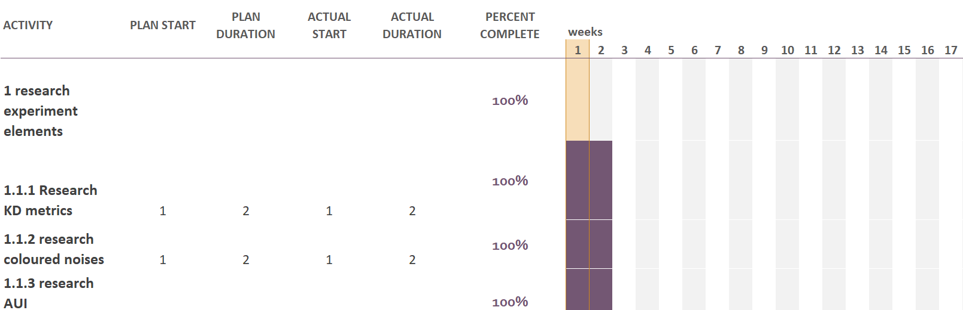
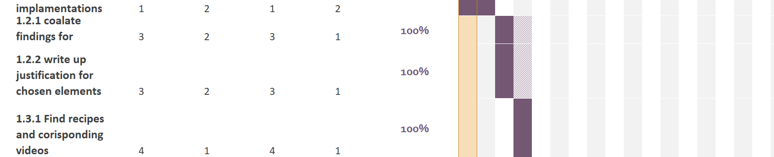
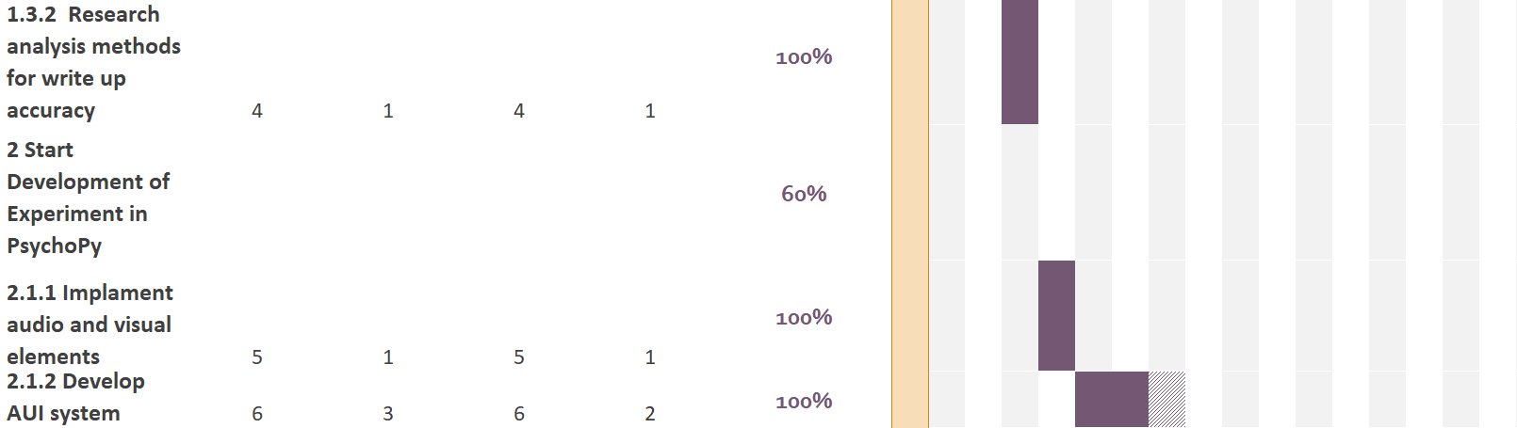
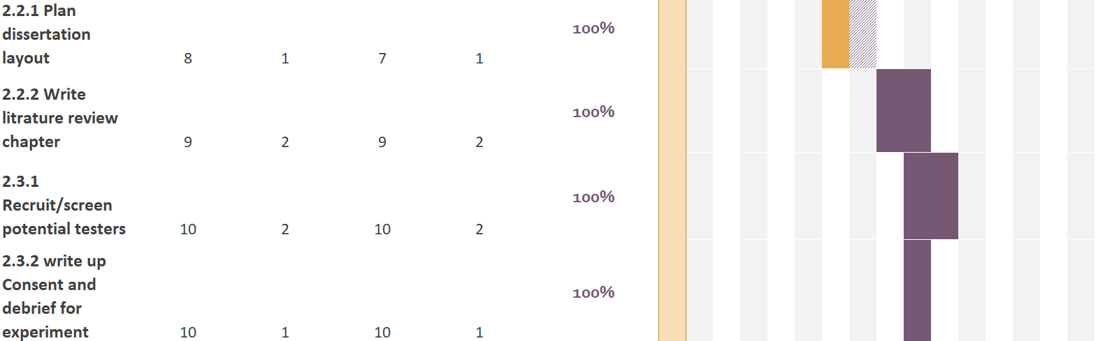
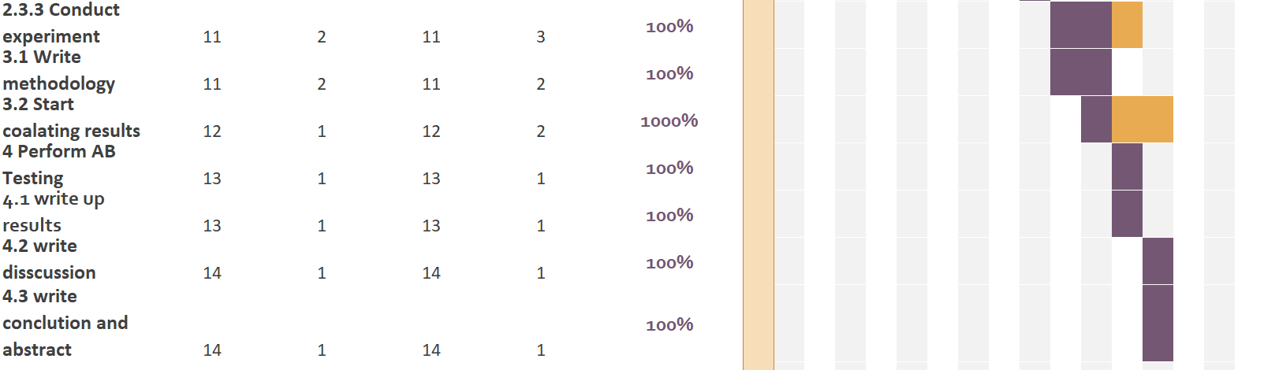
True 1903299 Masters Gantt Chart.xlsx

Appendix B Code Components
Simple task
Begin Routine
pause_times = []
last_key_time = None
typing_clock = core.Clock()
if counterbalance.group == '1':
print(counterbalance.group)

Each Frame
# Check for any new keypress
keys = event.getKeys(timeStamped=typing_clock)

for key, timestamp in keys:
if last_key_time is not None:
pause = timestamp - last_key_time
if pause > 0.15 and pause < 1.5:
pause_times.append(pause)
last_key_time = timestamp

End Routine
import numpy as np

if len(pause_times) >= 2:
p75 = np.percentile(pause_times, 75)
else:
p75 = None # Not enough data

expInfo['pause_p75'] = p75
thisExp.addData('pause_p75', p75)
print(pause_times[1], pause_times[10])
print(expInfo['pause_p75'])

Complex task
Begin Routine
pause_times = []
recentBackspaces = []
last_key = None
last_key_time = 0.0
valid_pauses = 0
typing_clock = core.Clock()
delCheck = False
IKICheck = False
del_event = []
pause_event = []
noise_to_pink =[]
keyLog = []

Each Frame
# Get new keypresses with timestamps
keys = event.getKeys(timeStamped=typing_clock)

for key, timestamp in keys:
keyLog.append({'key': key, 'time': timestamp})
if key == 'backspace':
recentBackspaces.append(timestamp)
else:
pause_times.append((key,timestamp))

current_time = typing_clock.getTime()
recentBackspaces = [t for t in recentBackspaces if current_time - t <= 10]
pause_times = [(key,time) for key, time in pause_times if current_time - time <= 10]

if len(recentBackspaces) >= 4:
# Get the most recent backspaces
recent_four = recentBackspaces[-4:]
time_window = recent_four[-1] - recent_four[0]

if time_window <= 5.0:
#print("5 backspaces within 5 seconds!")
delCheck = True
del_event.append(typing_clock.getTime())
else:
#print("not enough back spases1")
delCheck = False
else:
#print("not enough back spases2")
delCheck = False

for x in range(len(pause_times)):
key, time = pause_times[x]

if (key in [' ', '.']) or (last_key in [' ', '.']):
print(". occoured")
last_key = key
last_key_time = time
continue

pause = time - last_key_time
last_key = key
last_key_time = time

if pause > expInfo['pause_p75']:
valid_pauses += 1
#print('valid pause+1')

#print('total valid pauses' + str(valid_pauses))
if valid_pauses >= 5:
#print('valid pause >= 5')
pause_event.append(typing_clock.getTime())
valid_pauses = 0
IKICheck = True
else:
IKICheck = False

valid_pauses = 0

if counterbalance.group == '1':
if delCheck == True and IKICheck == True:
pink_2.setVolume(0.45)
white_2.setVolume(0.0)
noise_to_pink.append(typing_clock.getTime())
else:
pink_2.setVolume(0.0)
white_2.setVolume(0.45)
else:
if delCheck == True and IKICheck == True:
noise_to_pink.append(typing_clock.getTime())

End Routine
import json

participant_id = expInfo['participant']
allKeys = ';'.join([f" - {k['key']} {k['time']:.3f} - " for k in keyLog])
filename = f"KD_data_participant_{participant_id}.json"
with open(filename, 'w') as f:
json.dump({
'deleteEvents': del_event,
'pauseEvents': pause_event,
'noiseToPink': noise_to_pink,
'allKeys': keyLog
}, f)
thisExp.addData('task_end_time', typing_clock.getTime())

Appendix C Experiment Elements
Recipes
Pancakes
Ingredients
1 egg
1/4 cup sugar
pinch of salt
1/2 cup milk
1.5 tbsp oil
1 tsp of vanilla essence
1 cup all purpose flour
1 tsp baking powder
butter
maple syrup

Method

1. add egg, sugar, milk, oil and vanilla essence to a bowl and mix
2. add flour and baking flour and mix until the batter has a smooth texture
3. oil a frying pan then take 2 tbsp of batter and add to the pan on medium heat
4. wait until bubbles stop forming and then flip and cook for another 1.5 to 2 minuets
5. serve with butter and maple syrup

https://www.youtube.com/watch?v=NCMKedZvnyI

Georgian Cheese Bread
Ingredients:
240g Flour
50ml Milk
100ml Water
2-3g Dry Yeast
5-6g Salt
15g Sugar
30g Oil
100-120g Feta Cheese
200g Cottage Cheese
100g Mozzarella
3 Eggs

method

1. add milk, water, yeast and sugar to a bowl
2. Gradually add flower while stirring until mixture starts clumping together
3. add oil and mix thoroughly until mixture solidifies into sticky ball
4. mix salt into the dough
5. flour a surface and knead the dough until it becomes elastic
6. grease a bowl and rest dough for 45 to 50 minuets
7. fold dough on its self 3 times and portion
8. roll dough into to a rectangular shape 5 mm thick
9. for the filling add cream cheese, crumbled feta cheese and grated mozzarella to a bowl setting some aside for the filling
10. cover the top of the dough a layer of the filling and roll the long sides of the dough inwards ensuring the filling is inside the roll. but leave a space in the middle.
11. twist the ends of the two rolls together and fold the end under the dough buts still leave an opening on top of the dough
12. sprinkle with some cheese and let reast for 15 minuets.
13. add some dill to the opening, egg wash the top of the dough and add the remaining mozzarella cheese on top
14. bake in oven at 200 c for 20 minuets
15. add a whole egg to the opening and bake for another 5 to 7 minuets

https://www.youtube.com/watch?v=FgXE2ELOf1c

SUS Survey questions/ PDAQ questions
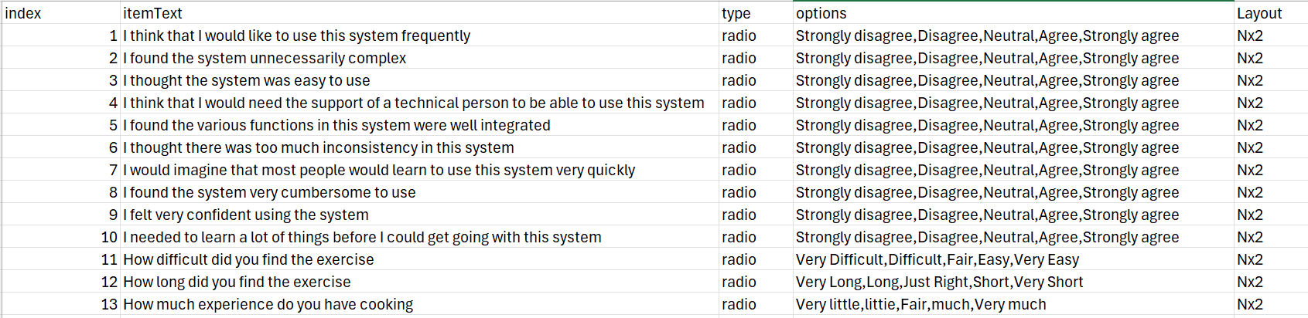
UEQ Survey question
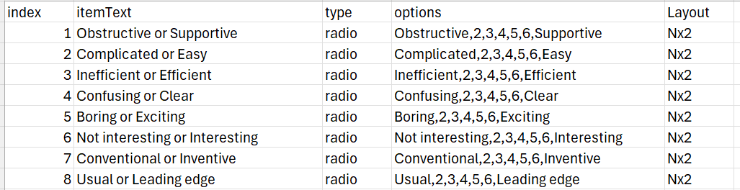

Appendix D Analysis
Normality Tests

 | Control W | Adaptive W | Control P | Adaptive P
RR | 0.976 | 0.887 | 0.937 | 0.060
DET | 0.698 | 0.975 | <.001 | 0.922
Lmean | 0.928 | 0.871 | 0.254 | 0.035
ENTR | 0.954 | 0.920 | 0.589 | 0.195
LAM | 0.756 | 0.937 | 0.001 | 0.346
TT | 0.909 | 0.951 | 0.129 | 0.546
Levenshtein Edit Distance | 0.964 | 0.858 | 0.761 | 0.023
Levenshtein Similarity Ratio | 0.957 | 0.858 | 0.636 | 0.023
Total Task Time | 0.912 | 0.971 | 0.146 | 0.874
Time Delete Flag Active | 0.965 | 0.976 | 0.785 | 0.931
Time Pause Flag Active | 0.734 | 0.952 | <.001 | 0.556
Time adaptation was Active | 0.893 | 0.687 | 0.075 | <.001
System Useability Survey | 0.917 | 0.934 | 0.174 | 0.316
User Experience Questionnaire Score | 0.945 | 0.954 | 0.451 | 0.59
Perceived difficulty of the Task | 0.692 | 0.694 | <.001 | <.001
Perceived Length of the Task | 0.694 | 0.763 | <.001 | 0.001
Experience Cooking | 0.896 | 0.83 | 0.082 | 0.009

Independent samples T-tests
RQA
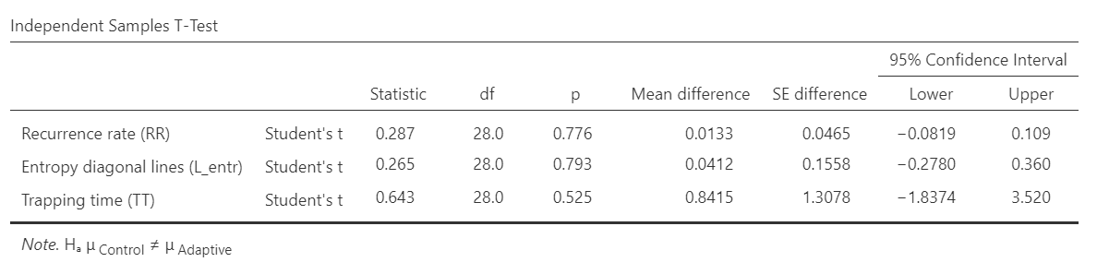
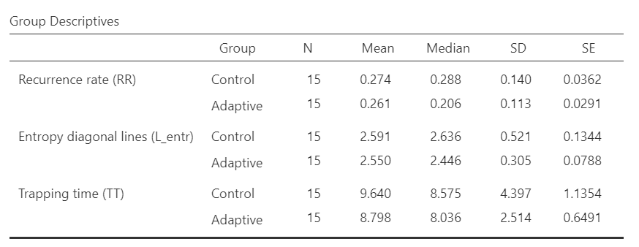

KD
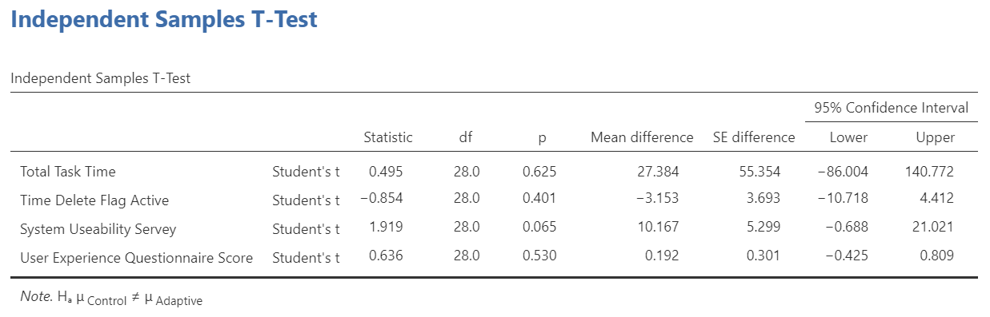
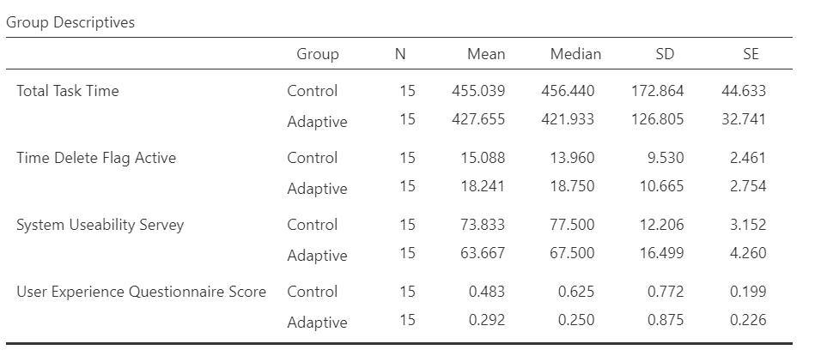

Mann-Whitney U Test Ranks
RAQ
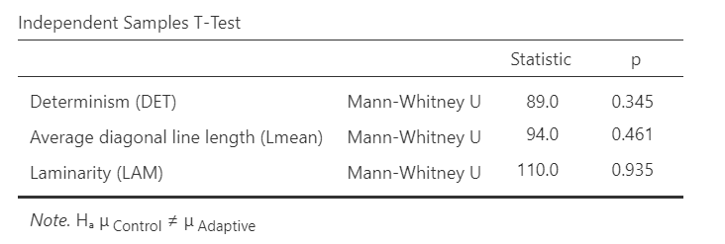

KD

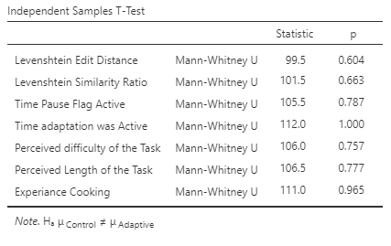

RQA Plots
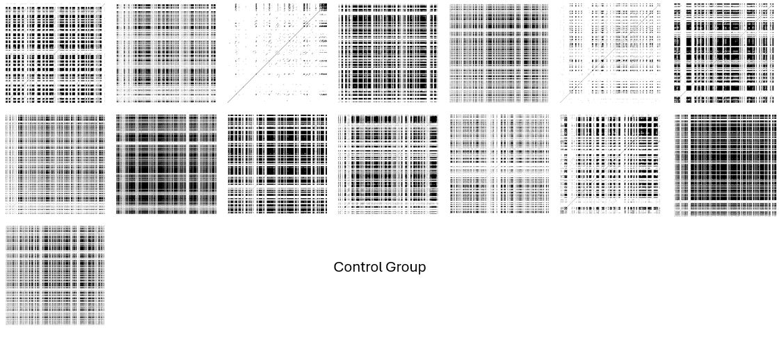
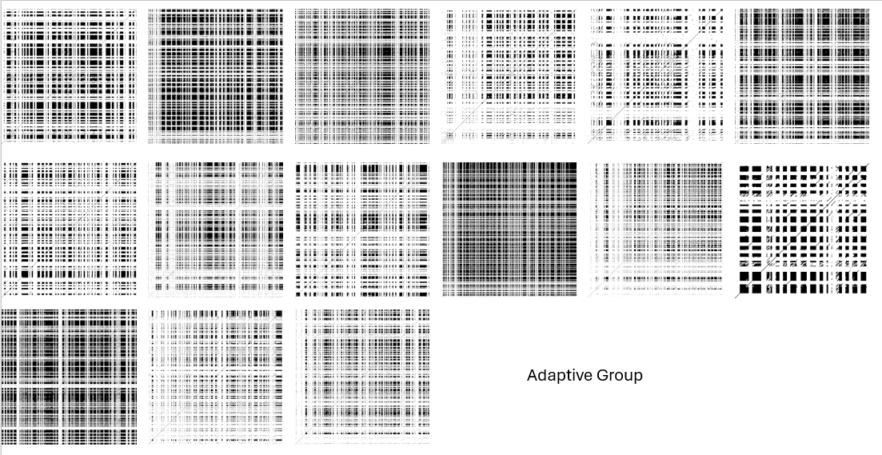
Recurrence Rate
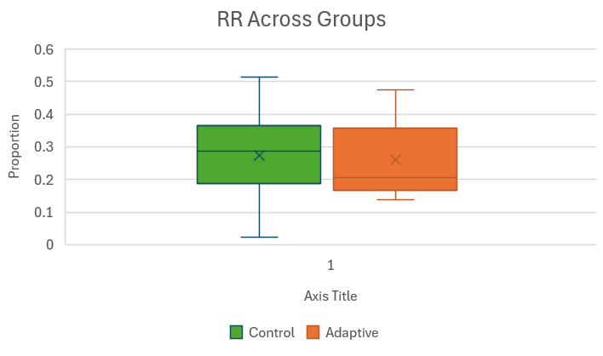

Determinism
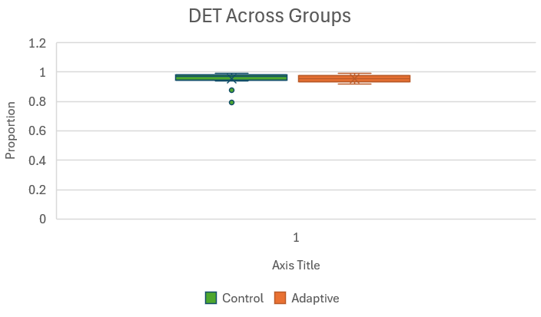

Average Diagonal Line length
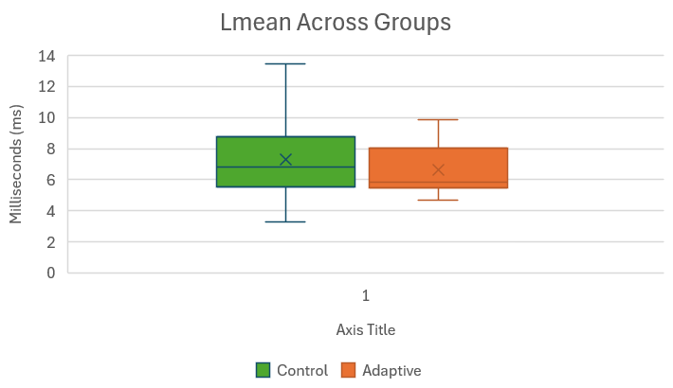
Entropy
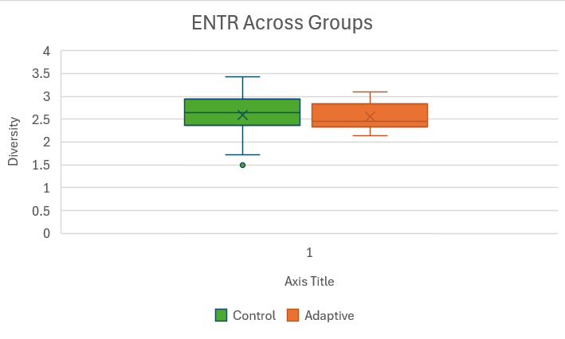

Laminarity
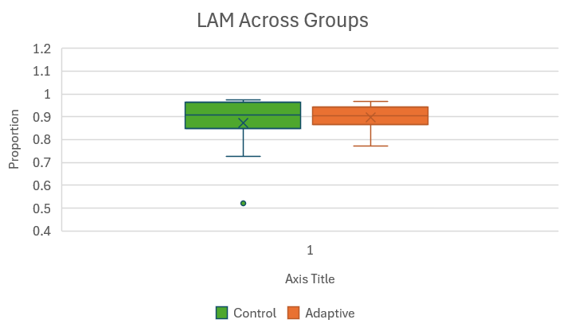

Trapping Time
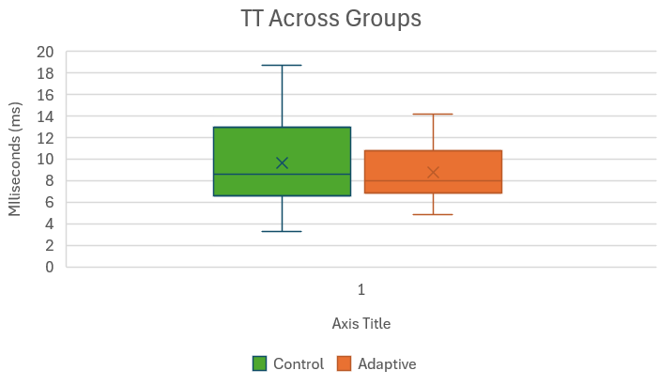

levenshtein edit

levenshtein Ratio

Total time to complete tasks
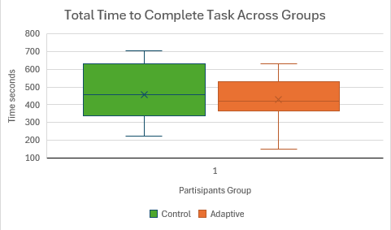

Percentage time delete flag was active
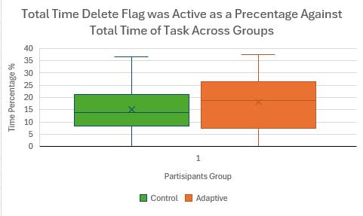

Percentage time pause flag was active
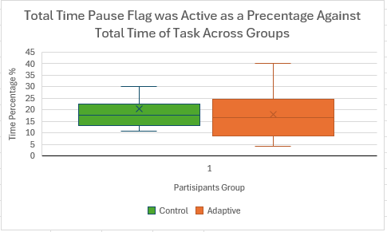

Percentage time adaptation was active
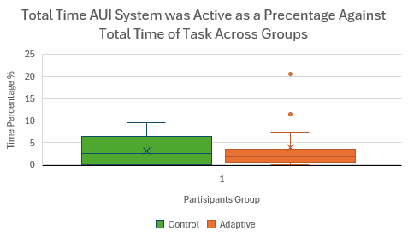

Perceived Task Difficulty
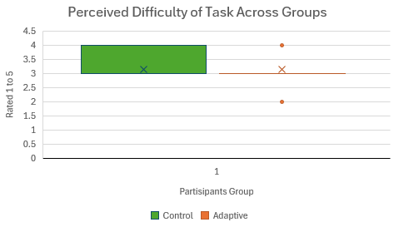

Perceived Task Length
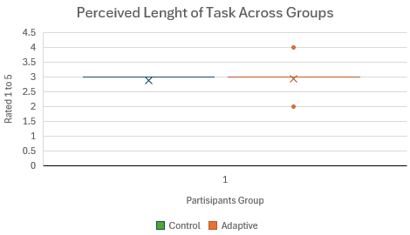

Experience With Cooking
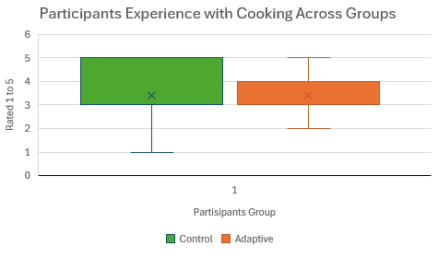

Appendix E: GDPR Data Management Data Sign Off Form

For undergraduate or postgraduate student projects supervised by an Abertay staff member.
This form MUST be included in the student’s thesis/dissertation. Note that failure to do this will mean that the student’s project cannot be assessed/examined.
Part 1: Supervisors to Complete
By signing this form, you are confirming that you have checked and verified your students’ data according to the criteria stated below (e.g., raw data, completed questionnaires, superlab/Eprime output, transcriptions etc.)

Student Name: | Connor Murphy
Student Number: | 1903299
Lead Supervisor Name: | Prof Vera Kempe
Lead Supervisor  Signature | 
Project title: | Adaptive UI as an office work support tool using changes in ambient noise
Study route: | PhD | MbR | MPhil
Study route: | Undergraduate | Postgraduate taught  X | PhD by Publication
Part 2: Student to Complete

Initial here to
confirm ‘Yes’
I confirm that I have handed over all manual records from my research project (e.g., consent forms, transcripts) to my supervisor for archiving/storage | CM
I confirm that I have handed over all digital records from my research project (e.g., recordings, data files) to my supervisor for archiving/storage | CM
I confirm that I no longer hold any digital records from my research project on any device other than the university network and the only data that I may retain is a copy of an anonymised data file(s) from my research | CM
I understand that, for undergraduate projects, my supervisor may delete manual/digital records of data if there is no foreseeable use for that data (with the exception of consent forms, which should be retained for 10 years) | CM

Student signature: CMurphy
Date: 16/08/25

